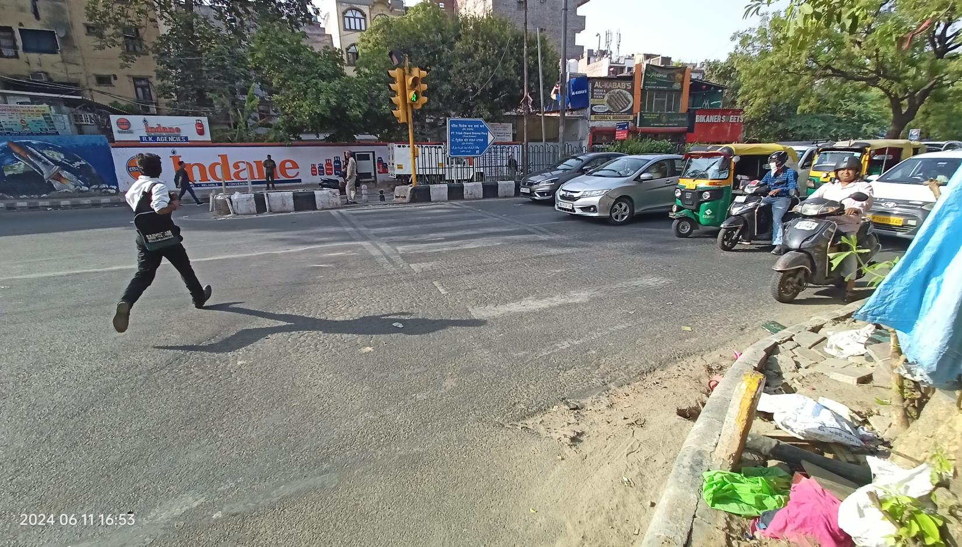



dELHI SOUTH DISTRICT ROAD SAFETY REPORT



**Report by:**



**Data support by:**

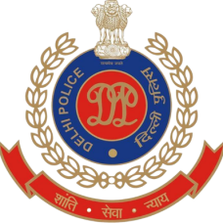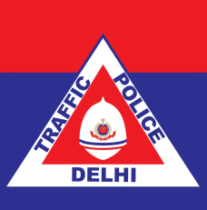

**Supported by:**







Table of Contents

List of Figures and Tables 1

List Of Abbreviations 3

Key Highlights 5

Introduction 6

Methodology 7

ABOUT THE DISTRICT 8

A : Road safety situation and trends in South district 9

A.1 : Road crash death trends 9

A.1.1 : Fatal road crashes and fatalities trend. 9

A.1.2 : Road crash fatalities by road user types 10

A.1.3 : Road crash deaths by month 11

A.1.4 : Road crash deaths by time and day of week 12

A.2 : Road crash deaths by age and gender 13

A.2.1 : Road crash deaths by gender 13

A.2.2 : Road crash deaths by age-groups and gender 13

A.3 : Road crash deaths by road user type 14

A.3.1 : Total Road crash deaths by road user type (2019, 2021, 2022) 14

A.3.2 : Timewise Road crash deaths by Road user type 15

A.3.3 : Who-hit-whom matrix 16

A.4 : Hit-and-runs in fatal road crashes 17

A.4.1 : Percentage of hit-and-run and non-hit-and-run cases 17

A.4.2 : Hit-and-run Road user types 17

A.5 : Road Crash Heatmaps 18

A.5.1 : Heatmap of all road crash deaths 18

A.5.2 : Heatmap of all pedestrian deaths 18

A.5.3 : Heatmap of all motorcycle (rider + pillion) related deaths 19

A.6 : High Risk Locations 20

A.6.1 : List of high-risk locations 20

A.6.2 : Map of all high-risk locations 20

A.6.3 : High risk corridors 21

B : Data to Action 22

B.1 : Lado Sarai Intersection 22

B.1.1 : General Description of the site 22

B.1.2 : Existing Land Use 22

B.1.3 : Conflict Points 23

B.1.4 : Existing Scenario 23

B.1.5 : Issues Identified 24

B.1.6 : Proposed Design 26

: Summary budget estimates 27

B.2 : DJB Saket Intersection 32

B.2.1 : General description of the site 32

B.2.2 : Existing Land Use 32

B.2.3 : Existing Scenario 33

B.2.4 : Issues identified 34

B.2.5 : Proposed Design 34

B.2.6 : Summary budget estimates 36

B.3 : Safe School Zone: DAV Vasant Kunj 41

B.3.1 : General description of the site 41

B.3.2 : Existing Scenario 42

B.3.3 : Issues identified 43

B.3.4 : Activity map 44

B.3.5 : Proposed design 47

# List of Figures and Tables

Figure 1 : South district map 9

Figure 2 : Fatal Road crashes and fatalities trend 10

Figure 3 : Road crash fatalities by road user types 11

Figure 4 : Average Road crash deaths by months 12

Figure 5 : Road cash deaths by gender 14

Figure 6 : Road crash deaths by age groups and gender 14

Figure 7 : Road crash deaths by road user type (2019, 2021, 2022) 15

Figure 8 : Timewise Road crash deaths by road user types 16

Figure 9 : Percentage of hit-and-run and non-hit-and-run cases 18

Figure 10 : Hit-and-run Road user types 18

Figure 11 : Heatmap of all road crash deaths in South district 19

Figure 12 : Heatmap of all pedestrian deaths due to road crashes in South District 19

Figure 13 : Heatmap of all motorcycle related deaths due to road crashes in South District 20

Figure 14 : Map of all high-risk locations intervened in South District 21

Figure 15 : Vulnerable Road users on corridors 22

Figure 16 : Vulnerable Road users’ death per km 22

Figure 17 : Lad oSarai Intersection Intersection satellite image 23

Figure 18 : Existing land use around Lado Sarai Intersection 23

Figure 19 : Conflict points at Lado Sarai Intersection 24

Figure 20 : Existing scenario of Lado Sarai Intersection 24

Figure 21 : Issues identified at Lado Sarai Intersection 25

Figure 22 : Proposed design for Lado Sarai Intersection 27

Figure 23 : DJB Saket Intersectionsatellite image 33

Figure 24 : Existing land use near DJB Saket Intersection Intersection 33

Figure 25 : Existing scenario at DJB Saket Intersection 34

Figure 26 : Existing scenario at DJB Saket Intersection 34

Figure 27 : Proposed design for DJB Saket Intersection 35

Figure 28 : Land Use Map of DAV Vasant Kunj (AY 22-23) 42

Figure 29 : School Travel Data 43

Figure 30 : Site Photographs : Footpath with raised drains and parked cars in front of DAV Public School (Left), Aruna Asaf Ali intersection with lack of safety and traffic calming measures (Right) 44

Figure 31 : Activity mapping at DAV Vasant Kunj (Home to School - Up, and School to Home - Down) 46

Figure 32 : Proposed School Zone Plan for DAV Vasant Kunj 48

Figure 33 : Render of the proposed intervention front of DAV Vasant Kunj 49

Figure 34 : (Left) - Pilot School Zone South  District - Raised Crossings at Asaf Ali Marg Intersections 49

Figure 35 : (Right) - Pilot School Zone South - Students walking on safe and accessible pedestrian paths, cycle track 49

Figure 36 : (Left) - Pilot School Zone South - Student using Dedicated drop off zone. Learning aid, vendor spaces, green areas and waiting spaces integrated as part of pedestrian environments 50

Figure 37 : (Right) - Waiting area and street art in front of Government school 50

Figure 38 : (Left) - School students using the newly built segregated cycle track during school commute 50

Figure 39 : (Right) - Segregated Cycle Track with cycle parking separated by Multi Utility Zone with signages (as per IRC 67: 2022) and street lighting 50

Figure 40 : Safe NMT Infrastructure segregated on both sides (Left); Learning Aid integrated with NMT Infrastructure for students  (centre); Students walking to school from intersection (Right)  51

Figure 41 : Area between schools used as a shared space with SDG floor corner street art - safety promise and play and gym areas (Left): Students using the corner for waiting and learning about road safety principles (Right) 51

Table 1 : Road crash deaths by time and day of week 12

Table 2 : Who-hit-whom matrix 16

Table 3 : List of high-risk locations 20

# List Of Abbreviations

* **GNCTD** Government of National Capital Territory of Delhi
* **DM** District Magistrate
* **DMRC** Delhi Metro Rail Corporation
* **DRSC** District Road Safety Committee
* **DTC** Delhi Transport Corporation
* **DTP** Delhi Traffic Police
* **FIR** First Information Report
* **FOB** Foot Over Bridge
* **GIS** Geographic Information System
* **GT** Grand Trunk
* **HV** Heavy Vehicle
* **IACP** International Association of Chiefs of Police
* **IIT** Indian Institute of Technology
* **IPC** Indian Penal Code
* **IRC** Indian Road Congress
* **iRAD** Integrated Road Accident Database
* **ISBT** Inter State Bus Terminal
* **KM** Kilometre
* **LMV** Light Motor Vehicle
* **MACT** Motor Accident Claims Tribunal
* **MCD** Municipal Corporation of Delhi
* **MoRTH** Ministry of Road Transport and Highways
* **MPD** Master Plan for Delhi
* **MTW** Motorised Two-Wheeler
* **NCR** National Capital Region
* **NCT** National Capital Territory
* **NGO** Non-Governmental Organisation
* **NH** National Highway
* **NHAI** National Highways Authority of India
* **NIC** National Informatics Centre
* **NSP** Netaji Subhash Place
* **PCR** Police Control Room
* **QGIS** Quantum Geographic Information System
* **RSLA** Road Safety Lead Agency
* **SKV** Sarvodaya Kanya Vidyalaya
* **SOP** Standard Operating Procedure
* **TRIPC** Transportation Research and Injury Prevention Centre
* **UT** Union Territory
* **WHO** World Health Organisation

# Key Highlights

* Fatal road crashes increased from 59 to 77 from 2021 to 2022.
* Pedestrians comprised 40% of the fatalities and motorcyclists comprised 45% of the fatalities in 2022.
* A large number of fatal crashes occurred between 2200 to 0600 hours.
* Two out of three fatal crashes( 60 %) are hit-and-run cases.
* A large number of fatal crashes involving  pedestrians and motorcyclists were hit and run cases.
* The high-risk locations of the South District are Lado Sarai Intersection and DJB Saket Intersection.

# Introduction

There has been an increase of road crash fatalities in Delhi since the easing of pandemic mobility restrictions. Vulnerable road users such as pedestrians, two-wheeler occupants and three-wheeler occupants are most at risk of severe injuries and - in worst case scenarios - death in a road crash. This risk which hinders the basic right of mobility for the road users warrants that effective and evidence-based road safety interventions and programs must be implemented regularly and systematically to mitigate the effects of road crashes.

In the year 2023, the Transport Department released the ‘Data to Action’ report which analysed 2019 to 2021 data and identified high-risk locations for each of the eleven districts in Delhi. The report provided detailed maps, overall analysis for the National Capital Territory (NCT) of Delhi, and general recommendations for each district. The report was presented to the District Road Safety Committees (DRSCs) to guide them in implementing road safety interventions and address the most urgent road safety risk factors in their jurisdictions. The DRSCs take the lead in drafting the district road safety plan. They are instrumental in planning road safety interventions for high-risk locations in the district, implement interventions on the ground, and disburse road safety funds.

As a next logical step, to take evidence-based action in order to reduce crashes, the Transport Department are producing highly customised district specific road safety reports (DRSR) for the DRSCs. These reports include detailed findings on road crashes in the given district including a list of high-risk locations and provide specific recommendations to reduce crashes. The purpose of these DRSR is to guide DRSCs in implementing evidence-based interventions to reduce crash fatalities in high-risk locations and provide detailed infrastructure designs for specific locations which can be readily implemented on ground. The ultimate goal of this process is to inform and train the DRSC members in replicating the evidence-based action in the future.

# Methodology

Data Source

The District Road Safety Report (DRSRs) focused on road crash fatalities’ data in the National Capital Territory (NCT) of Delhi from the years 2019, 2021 and 2022. The data source for this report is police crash data records from the Motor Accident Claims Tribunal (MACT) cells of the Districts. In addition, this data is supplemented by the FIR lists from the Delhi Traffic Police. The dataset was compiled, digitised, and cleaned at the Transport Department.

Data Analysis

The digitised datasets were compiled and analysed using MS Access to produce descriptive statistics and were mapped using Quantum Geographic Information Systems (QGIS) platform, to identify high-risk locations including high-risk corridors in each district. Similar process will be followed for producing district road safety reports for the remaining districts.

On-site Investigation of High-risk Locations and Corridors

An in-depth and on-site investigation was conducted for the identified high-risk locations. At the site, both qualitative and quantitative data were collected which informed the design of the interventions. The data collection was based on the following parameters:

* Inspection of the road infrastructure and land use at the site.
* Identification of hazards and conflict points, especially pedestrians’ movement, bus stop locations.
* Assessment of the type and quality of enforcement
* Observations on road user behaviour, parked vehicles, street vendors and accessibility of vulnerable road users
* Identification of types of road users and traffic mix and speed.

These data points were collated and presented for the selected high-risk sites, and were used to inform the design of the proposed interventions.

Report Structure

Each district has a dedicated report. There will be a total of 11 reports - one for each district in NCT Delhi. The report is divided into three parts. The first part includes the introduction of road safety in the context of the district, and methodology that was followed to produce the report. The second part covers the discussion on the road safety situation in the given district. Finally, the last part of the report provides detailed investigation and recommendations for the selected high-risk sites in the district.

# ABOUT THE DISTRICT

The District of South Delhi is bounded by River Yamuna to the east, districts of New Delhi to the north, Faridabad district of Haryana to the south east and Gurgaon district of Haryana to the south west.

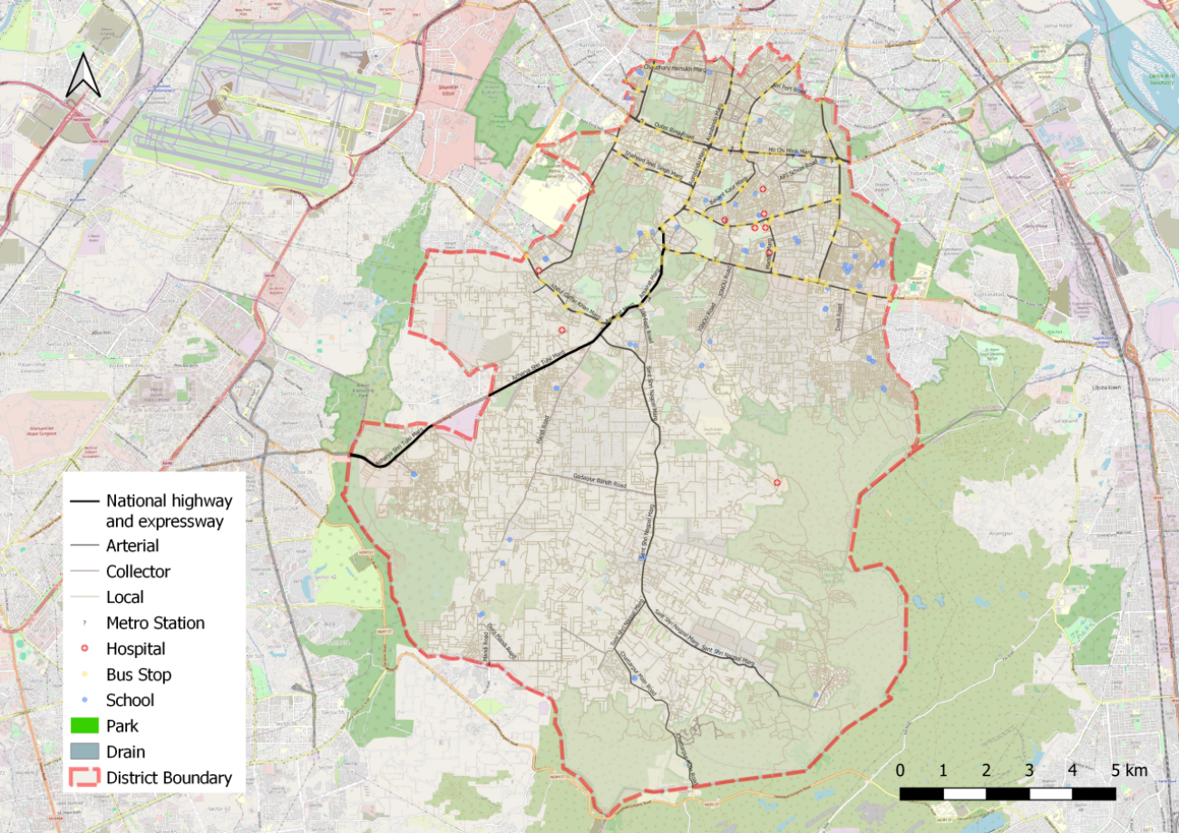

Figure 1: South district map

# **: Road safety situation and trends in South district**

## : Road crash death trends

### : Fatal road crashes and fatalities trend.

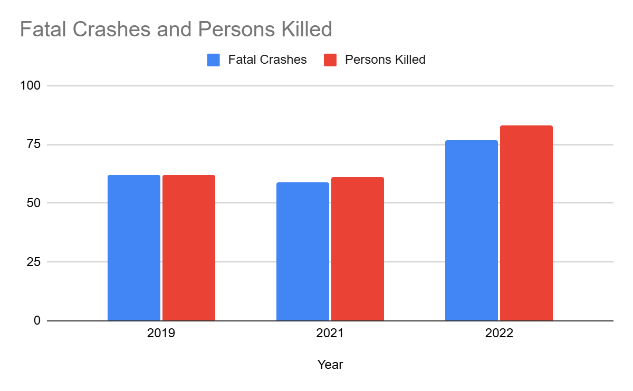

Figure 2: Fatal Road crashes and fatalities trend

There were 77 fatal road crashes in the South District of Delhi in 2022 with 83 persons killed in these crashes. There is a 30% increase compared to the previous year 2021 which is 59. One person is killed in road crashes in the South District every four to five days.

### : Road crash fatalities by road user types

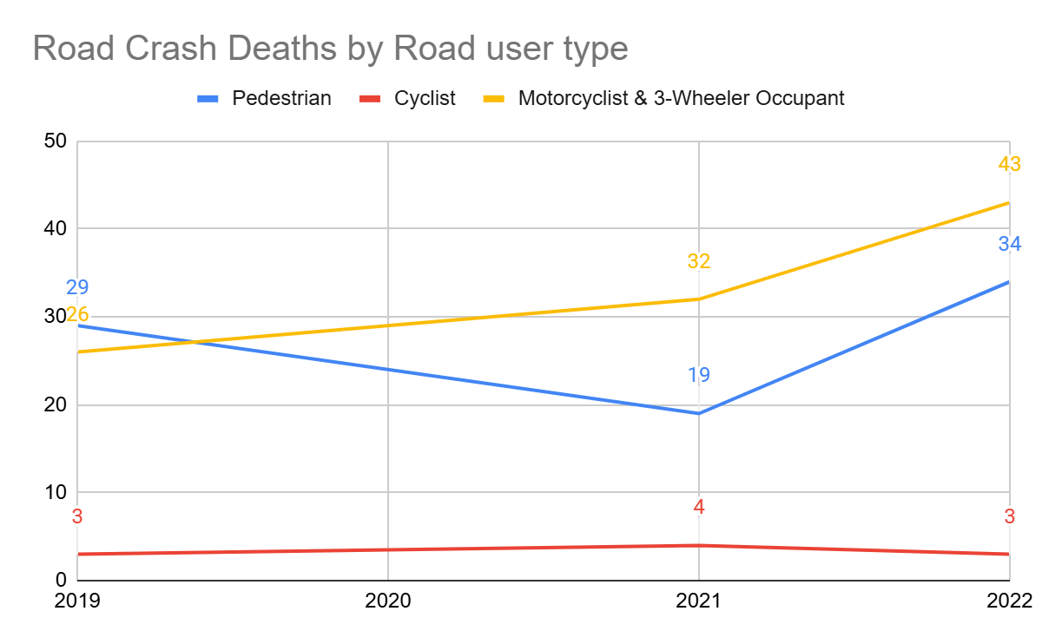

Figure 3: Road crash fatalities by road user types

Motorcyclists, auto rickshaw occupants and pedestrians formed a majority of persons killed in road crashes in the South District across all three years. Between the highlighted categories, the pedestrians’ fatalities surpassed the motorcyclist and autorickshaw occupants’ fatalities in 2021 and 2022.

### : Road crash deaths by month

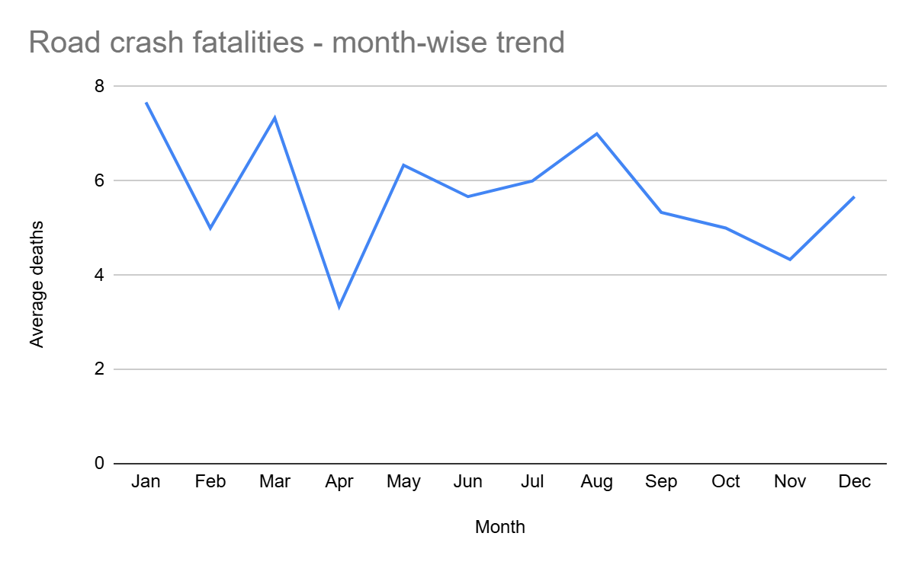

Figure 4: Average Road crash deaths by months

January and March witnessed the highest number of persons killed followed by August and May, there is no discernible pattern of fatalities by month.

### : Road crash deaths by time and day of week

|  |  |  |  |  |  |  |  |  |
| --- | --- | --- | --- | --- | --- | --- | --- | --- |
|  | **Monday** | **Tuesday** | **Wednesday** | **Thursday** | **Friday** | **Saturday** | **Sunday** | **Total** |
| **02:00-06:00** | 4 | 4 | 6 | 5 | 3 | 7 | 6 | **35** |
| **06:00-10:00** | 5 | 2 | 2 | 1 | 4 | 2 | 2 | **18** |
| **10:00-14:00** | 1 | 5 | 5 | 3 | 7 | 4 | 1 | **26** |
| **14:00-18:00** | 1 | 6 | 2 | 2 | 3 | 1 | 4 | **19** |
| **18:00-22:00** | 3 | 3 | 2 | 1 | 3 | 7 | 5 | **24** |
| **22:00-02:00** | 9 | 15 | 11 | 8 | 12 | 10 | 11 | **76** |
| **Total** | **23** | **35** | **28** | **20** | **32** | **31** | **29** | **198** |

Table 1: Road crash deaths by time and day of week

Thirty eight percent of the total road crash deaths occurred at night 10:00 pm to 2:00 pm. Thirty three percent of the total deaths occurred either on Fridays or on Tuesdays.

## : Road crash deaths by age and gender

### : Road crash deaths by gender

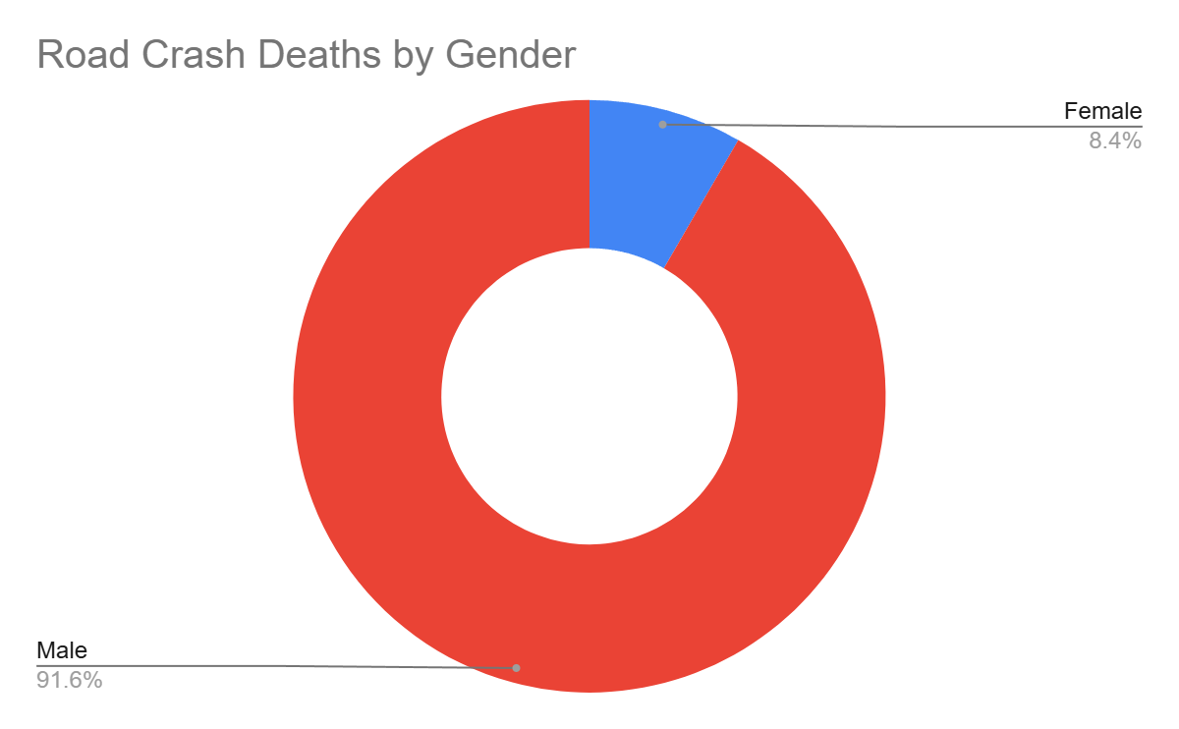

Figure 5: Road cash deaths by gender

### : Road crash deaths by age-groups and gender

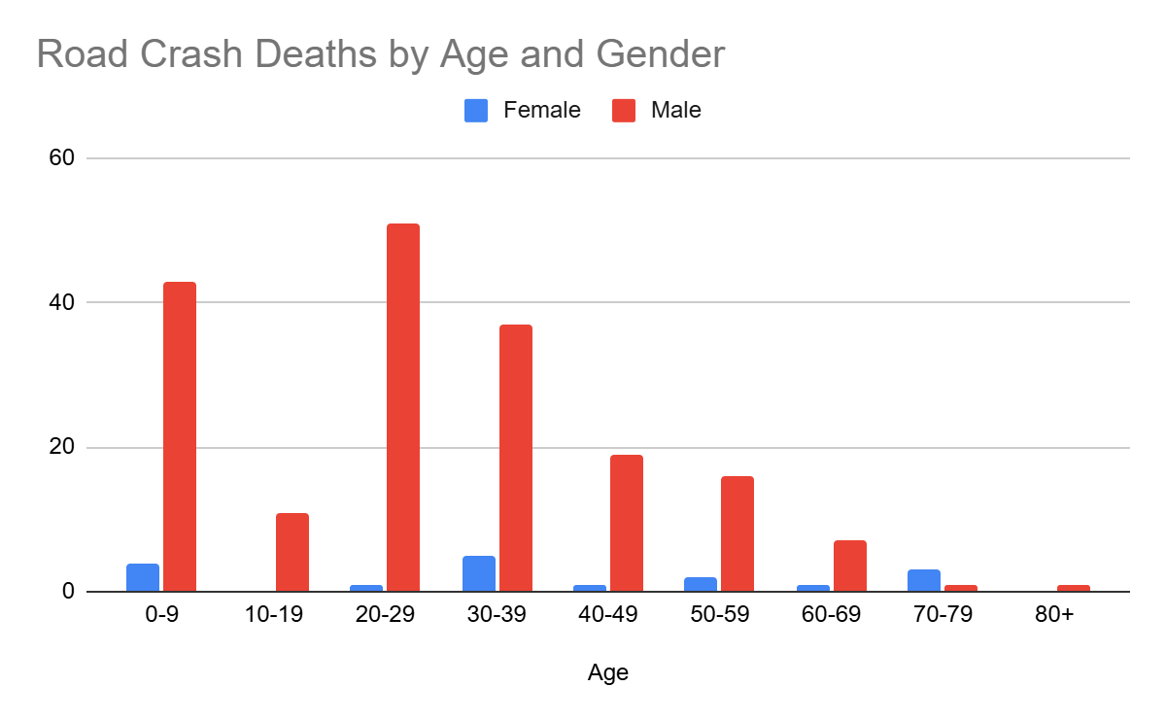

Figure 6: Road crash deaths by age groups and gender

Looking at the absolute numbers, the males had a higher number of fatalities 92% compared to females. Among the males, the fatalities were observed to be highest in the age group of 20-29 years, followed by 0-9 years.

## : Road crash deaths by road user type

### : Total Road crash deaths by road user type (2019, 2021, 2022)

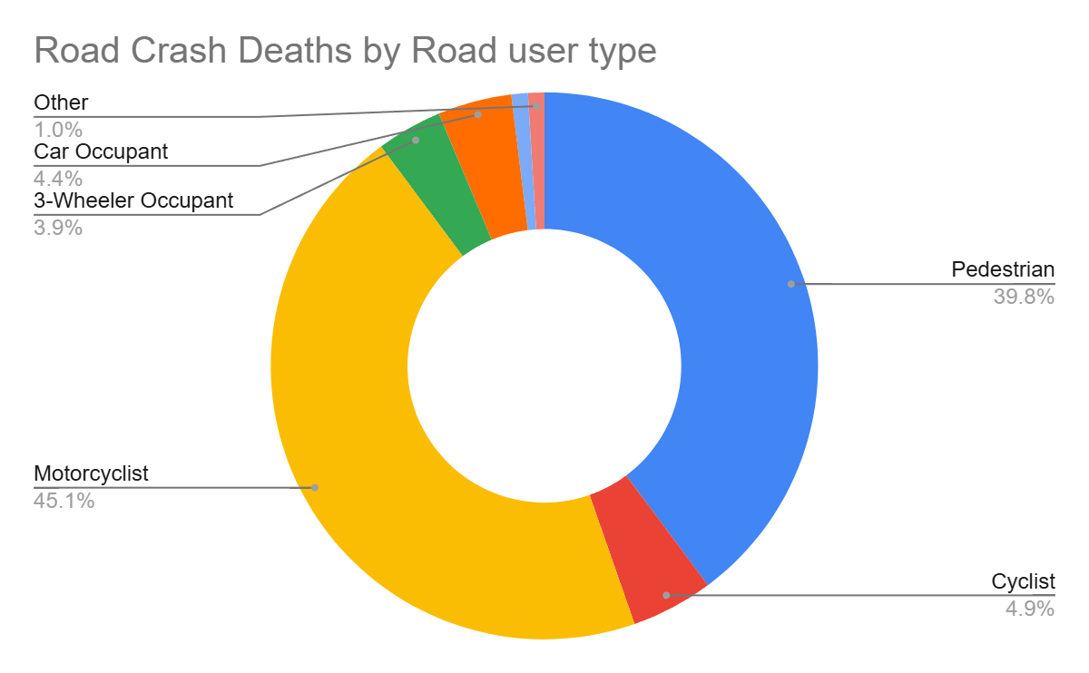

Figure 7: Road crash deaths by road user type (2019, 2021, 2022)

*Other includes cycle rickshaws, converted rickshaws and hand carts

Ninety-four percent of fatalities were among vulnerable road users (i.e., pedestrians, motorcyclists, cyclists, and auto rickshaw occupants). Among this, forty five percent of road crash deaths in the South district were among motorcyclists, followed by pedestrians (40%).

### : Timewise Road crash deaths by Road user type

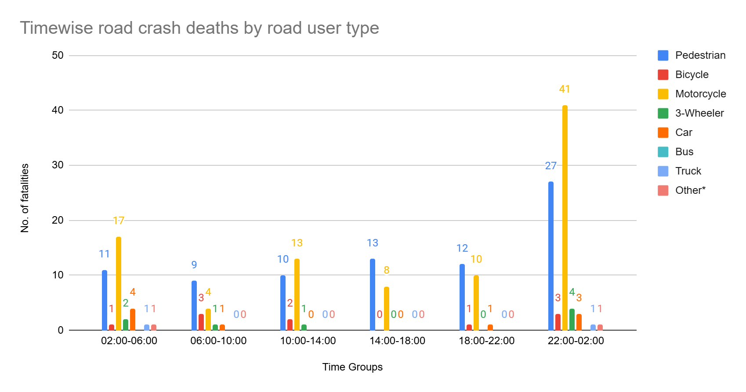

Figure 8: Timewise Road crash deaths by road user types

*Other includes cycle rickshaws, converted rickshaws and hand carts

### : Who-hit-whom matrix

|  |  |  |  |  |  |  |  |  |  |
| --- | --- | --- | --- | --- | --- | --- | --- | --- | --- |
| **Victim Road User** | **Impacting Vehicle** | | | | | | | | |
| **Motorcycle** | **3-Wheeler** | **Car** | **Bus** | **Truck/ Tractor** | **Single Vehicle Crash** | **Other** | **Unknown** | **Total** |
| **Pedestrian** | 10 | 2 | 14 | 3 | 6 | 0 | 0 | 47 | **82** |
| **Cyclist** | 3 | 0 | 4 | 1 | 0 | 0 | 0 | 2 | **10** |
| **Motorcyclist** | 4 | 0 | 11 | 6 | 17 | 10 | 2 | 43 | **93** |
| **3-Wheeler Occupant** | 0 | 2 | 2 | 0 | 1 | 1 | 0 | 2 | **8** |
| **Car Occupant** | 0 | 1 | 2 | 2 | 0 | 0 | 0 | 4 | **9** |
| **Truck Occupant** | 0 | 1 | 1 | 0 | 0 | 0 | 0 | 0 | **2** |
| **Other** | 0 | 0 | 2 | 0 | 0 | 0 | 0 | 0 | **2** |
| **Total** | **17** | **6** | **36** | **12** | **24** | **11** | **2** | **98** | **206** |

Table 2: Who-hit-whom matrix

Note: Other includes cycle rickshaws, converted rickshaws and hand carts

Among all fatal road crashes where the impacting vehicle was known, pedestrians and motorcyclists were found to be the most vulnerable category of road users. They were often hit by trucks and tractors. Hit-and-run crashes dominate both the categories of cases where the impacting vehicle was not known for 47 cases in case of pedestrians and 43 in case of motorcyclists.

## : Hit-and-runs in fatal road crashes

### : Percentage of hit-and-run and non-hit-and-run cases

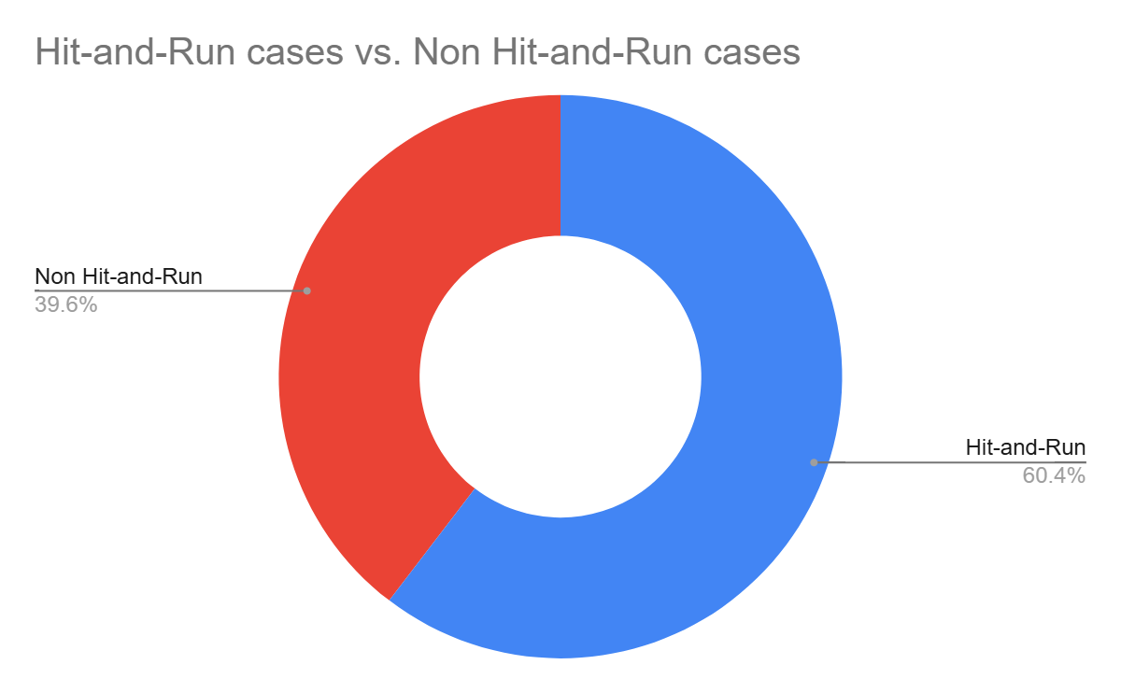

Figure 9: Percentage of hit-and-run and non-hit-and-run cases

Overall, two out of three crashes are hit-and-run cases. The high rate of hit-and-run cases is indicative of non-reporting of accused vehicles as well as non-reporting of crashes by the public.

### : Hit-and-run Road user types

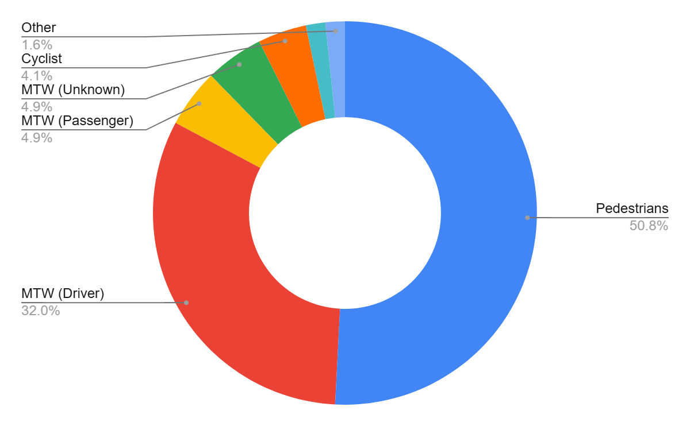

Figure 10: Hit-and-run Road user types

## : Road Crash Heatmaps

### : Heatmap of all road crash deaths

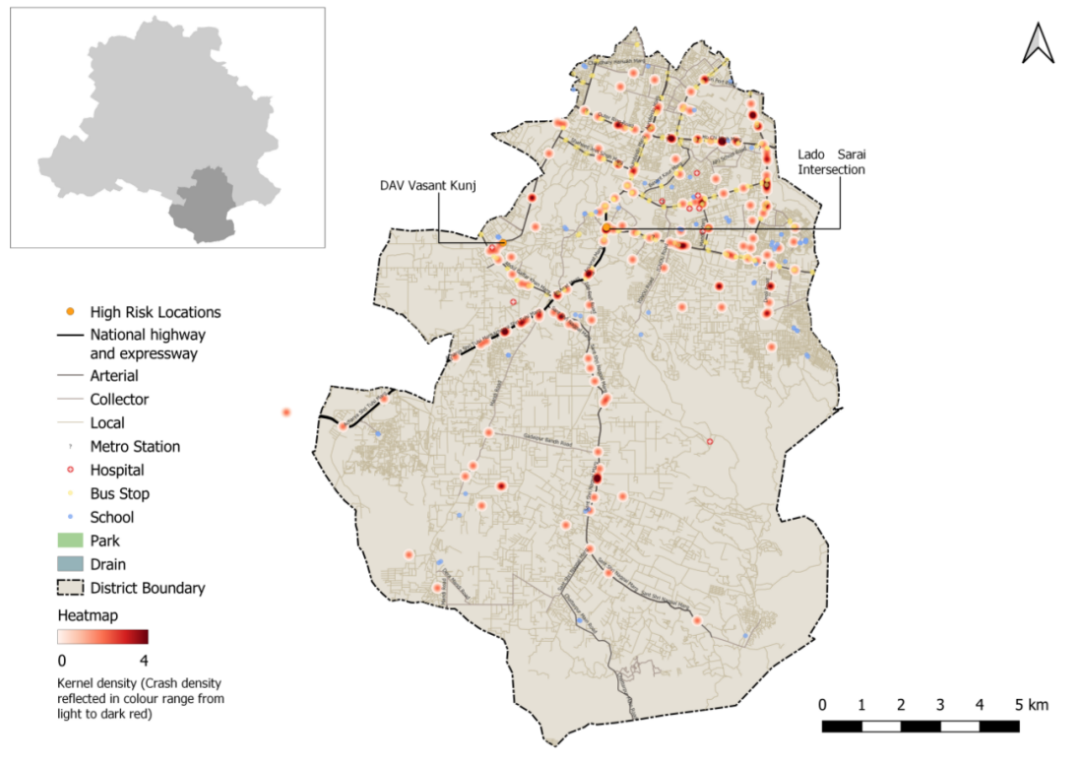

Figure 11: Heatmap of all road crash deaths in South district

### : Heatmap of all pedestrian deaths

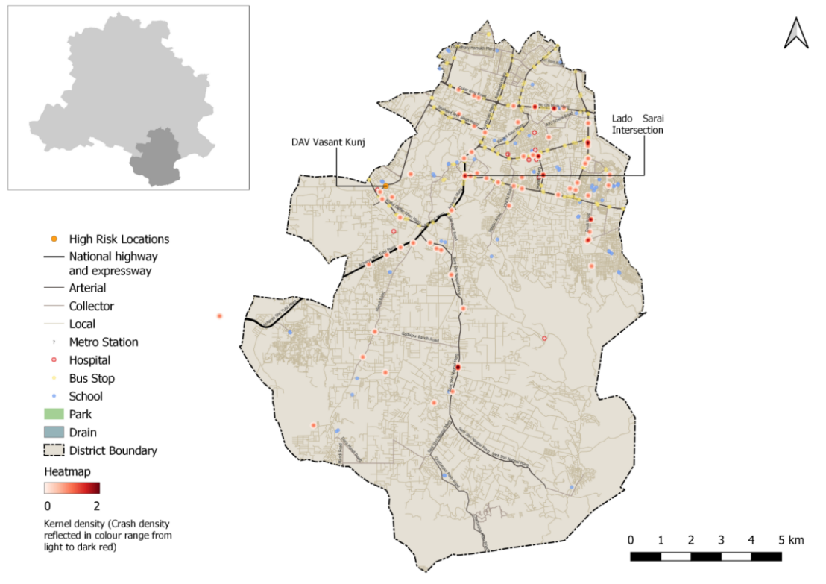

Figure 12: Heatmap of all pedestrian deaths due to road crashes in South District

### : Heatmap of all motorcycle (rider + pillion) related deaths

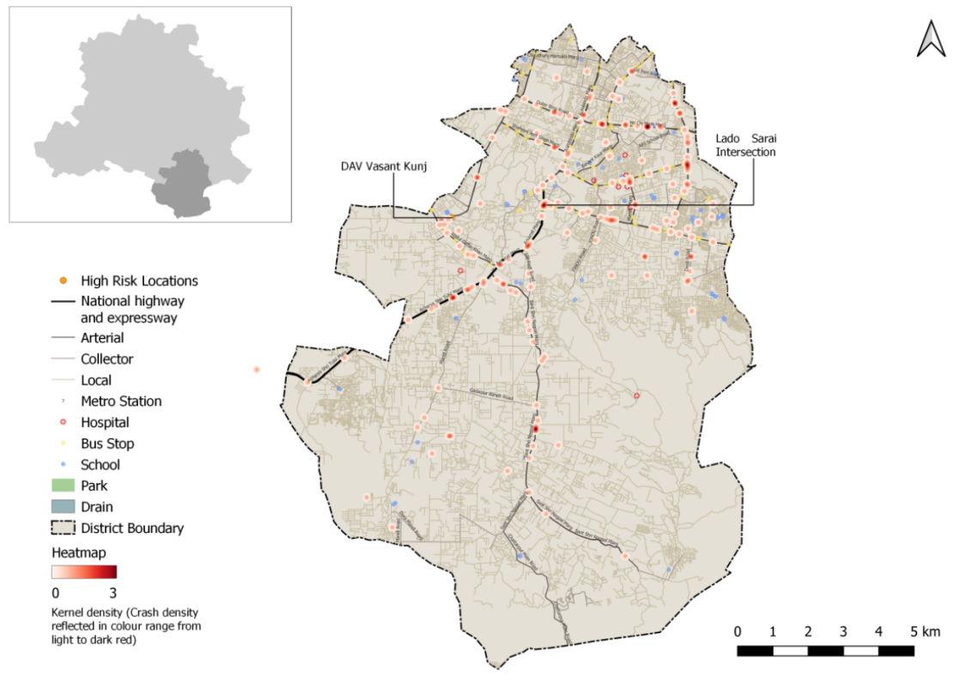

Figure 13: Heatmap of all motorcycle related deaths due to road crashes in South District

## : High Risk Locations

### : List of high-risk locations

The following is a list of high-risk locations in the South district which includes the number of fatal crashes, hit-and-run crashes, and deaths occurred during these crashes in years 2019, 2021 and 2022.

|  |  |  |  |
| --- | --- | --- | --- |
| **High Risk Location** | **Total fatal crashes** | **Total hit and run fatal crashes** | **Total persons killed** |
| Lado Sarai Intersection | 7 | 5 | 7 |
| DAV Vasant Kunj | 3 | 1 | 3 |

Table 3: List of high-risk locations

### : Map of all high-risk locations

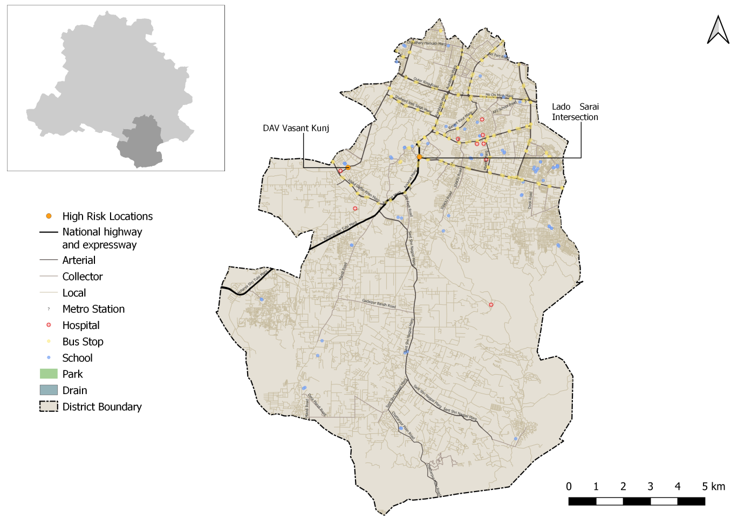

Figure 14: Map of all high-risk locations intervened in South District

### : High risk corridors

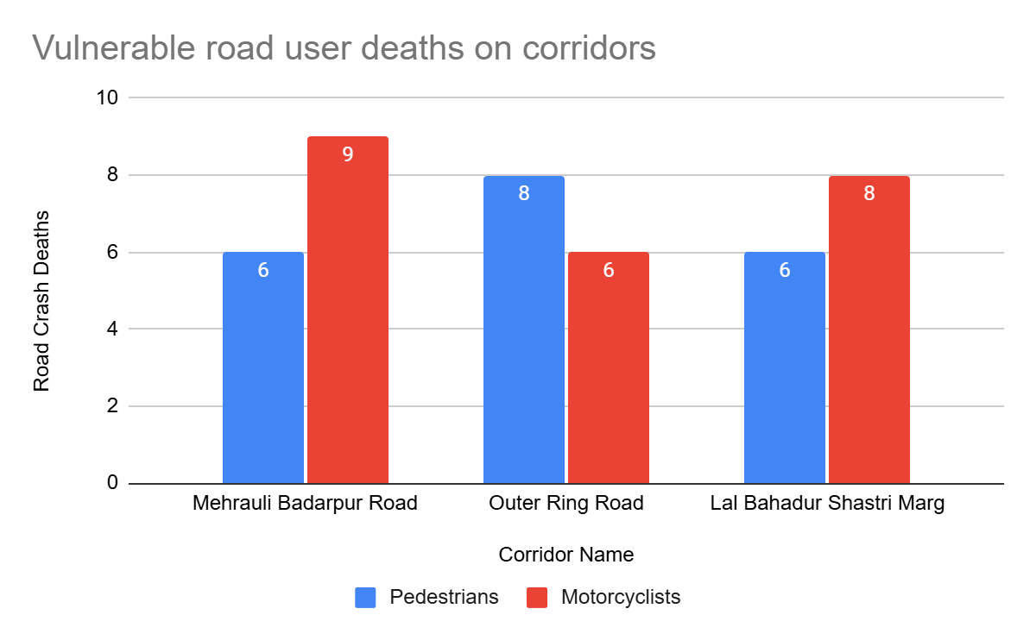

Figure 15: Vulnerable Road users on corridors

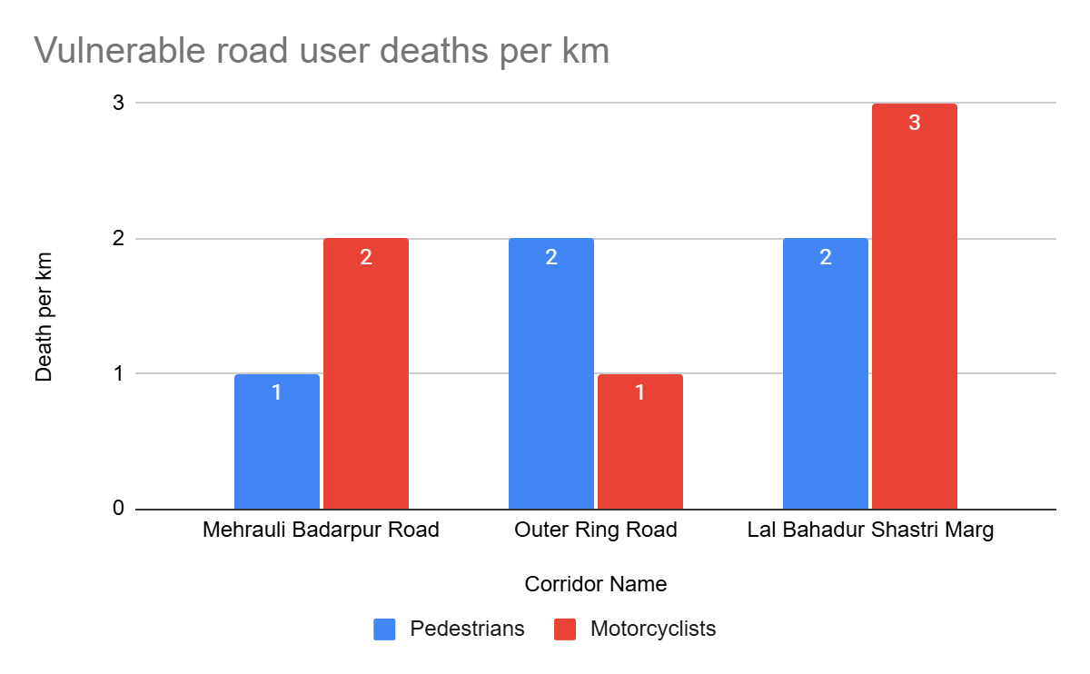

Figure 16: Vulnerable Road users’ death per km

# **: Data to Action**

## : LADO SARAI intersection

### : General Description of the site

Lado Sarai Intersection (Latitude:28°31'24.39"N, Longitude: 77°11'24.44"E). It is a T-intersection which is signalised. The intersecting road names are Mehrauli-Badarpur Road (Sub-Arterial Road) and Anuwat Marg (Collector Road).

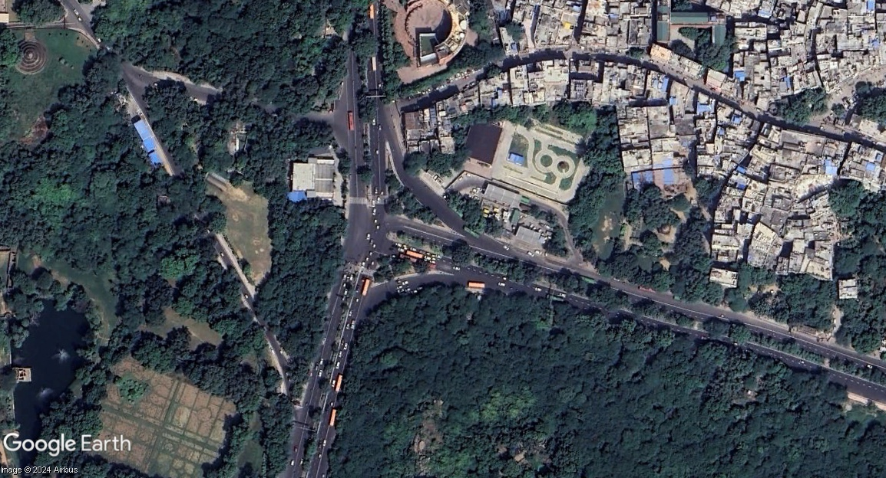

Figure 17: Lado Sarai Intersection Intersection satellite image

### : Existing Land Use

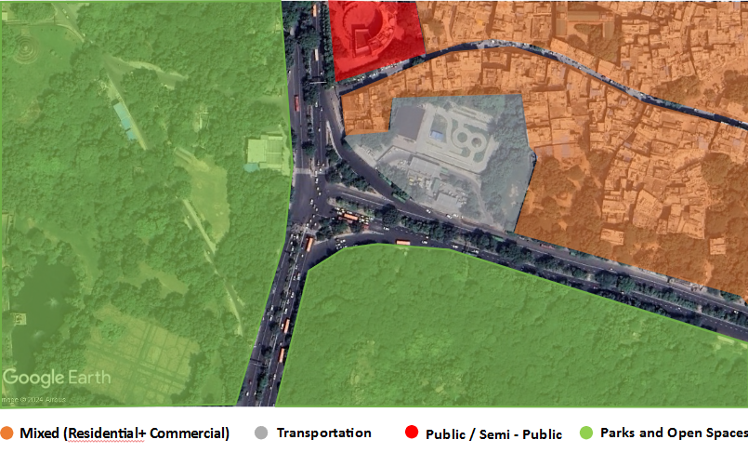

Figure 18: Existing land use around Lado Sarai Intersection

### : Existing Scenario

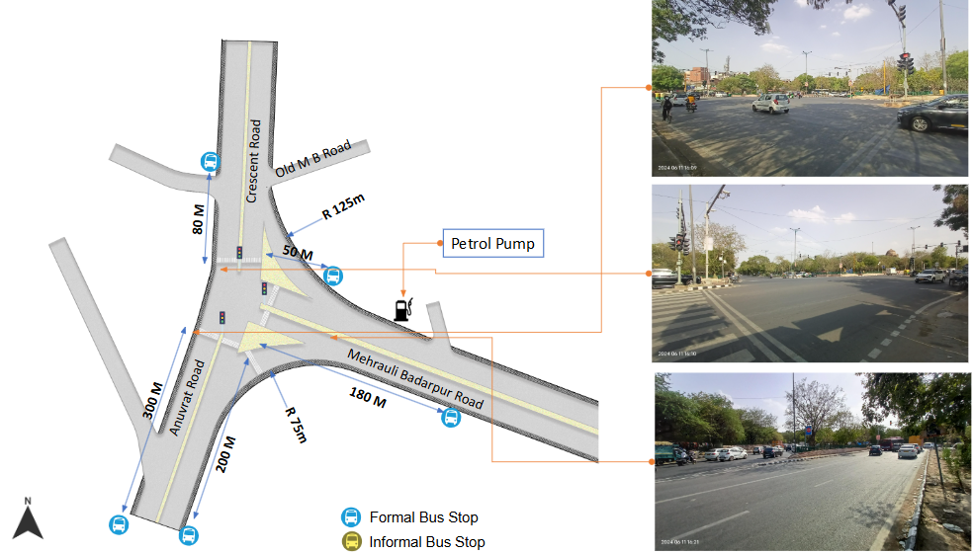

Figure 19: Existing scenario of Lado Sarai Intersection

### : Issues Identified

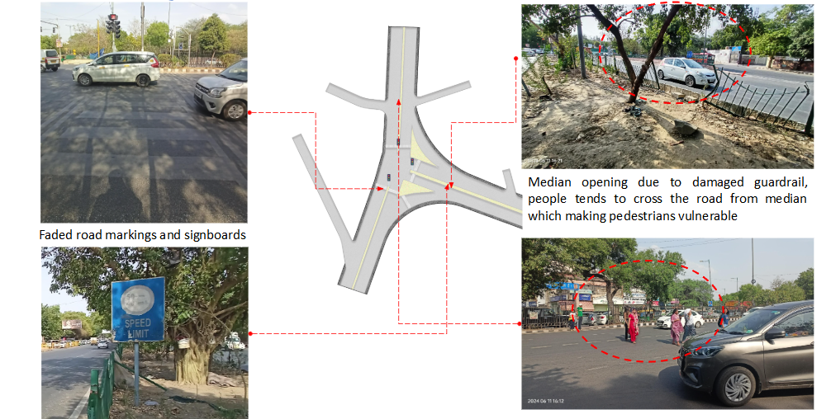

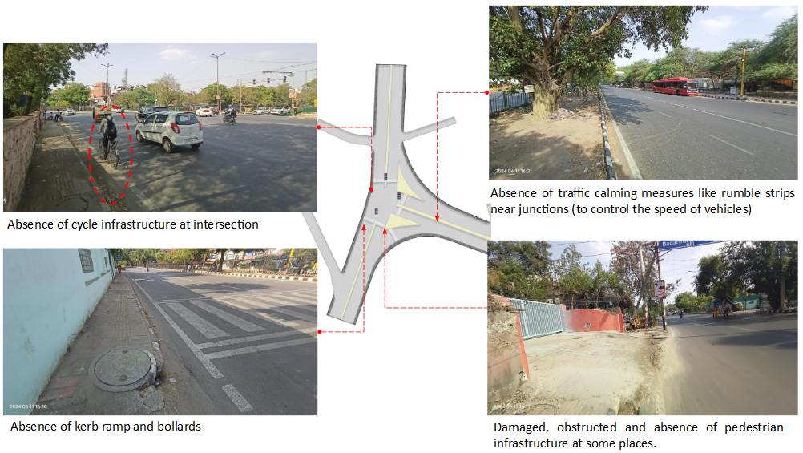

Figure 20: Issues identified at Lado Sarai Intersection

**Issues Identified:**

1. Absence of at-grade pedestrian infrastructure at the junction, making the pedestrians extremely vulnerable among the highspeed traffic movement.
2. Damaged and obstructed pedestrian infrastructure on each arm.
3. Damaged & uneven road surface and pedestrian infrastructure.
4. Absence of tactile flooring for differently abled users.
5. Absence of traffic calming near junctions (to control the speed of vehicles).
6. Absence of road markings, signages and speed control measures at the intersection.
7. Absence of delineators and reflectors on the median and carriageway edges.
8. Absence of segregated cycle tracks on arterial roads.

### : Proposed Design

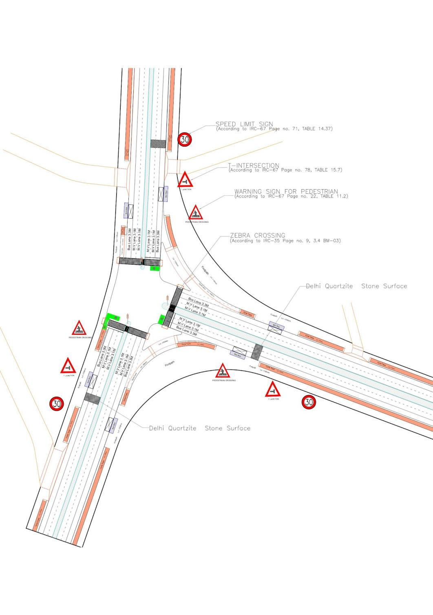

Figure 21: Proposed design for Lado Sarai Intersection

1. The junction is redesigned for the speed of 30 km/hr to ensure the safety
2. Proposed new bus stop near the junction to reduce the pedestrian crossing movement
3. Dedicated 2.5m wide cycle track to separate the motor traffic and the cyclists (as per IRC: 11-2022)
4. Installation of signages - Speed Limit, stop sign, pedestrian crossing and other necessary Signages on all approaching roads
5. Provision of Delhi Quartzite stone surface to slow down the approaching traffic
6. Demarcation of Road Markings (properly painted as per IRC 35)
7. Provision of kerb ramps for the accessibility of differently abled users (as per IRC:103-2022)

### 

### : Summary budget estimates

| **S.No** | **Component** | **Details** | **Notes** | **Rate (per sq.m)** | **Cost (INR)** | **Cost (INR, crores)** |
| --- | --- | --- | --- | --- | --- | --- |
| **A** | **CIVIL WORK** |  |  |  |  |  |
| A.1 | Footpath (Primary, Secondary including other Flooring area) | 2m to 3m wide segregated footpath with tactile pavers | Providing and Laying of footpath 2m to 3m wide, including earthwork and base layer - PCC, GSB and finsihing material. | 2628 | 12,089,172 | 1.209 |
| A.2 | Raised Crossing | Raised crssing with 80mm thick pavers and DQ stone surface | Providing and laying Raised crosseing with 80 mm thk pavers blocks, and DQ stone including Earth work and Base layers- PCC (M15), RCC (M30 Design mix) & GSB etc. | 3745 | 3,332,972 | 0.333 |
| A.3 | Cycle Infrastructure | 2.5m wide segregated cycle track | Providing and laying cycle track (2.5mt wide segregated) inculding Earth work and Base layers- PCC (M15), RCC (M40 Design mix) & GSB etc. also thermoplastic paint for marking and cycle symbol and spring post etc | 3916 | 4,895,406 | 0.490 |
| A.4 | CC Items (Kerbs, Pipe, etc) | Kerb stones, Bollards, Kerb Channels etc. | Providing and fixing Kerbs, Bollards , and Kerb Channel etc. in CC. |  | 1,327,666 | 0.133 |
| A.5 | Signages | Mandatory, Cautoniory and Informatory Sign Boards of different sizes | Providing and fixing Signage Mandatory, Cautonory and informatory sign board inculding all the fixing and labours etc. |  | 72,548 | 0.007 |
| A.6 | Marking | Thermoplastic Paint Marking (Edge lines, Centre Line, Lane Marking, Hazard Marking, Chevron, Zebra Crossing, Bar Marking, etc) | Providing and applying road marking strips (retro- reflective) of specified shade/ colour using hot thermoplastic material for road marking . | 748 | 367,918 | 0.037 |
| A.7 | Special Zones | Provision of Sitting Bollards, CC Benches, GRC Jali, Pergola, Dustbin etc. | Miscellaneous items- Provision of Sitting Bollards, CC Benches, GRC Jali, Pargola, Dustbin etc. complete items- including foundation and fixing etc. |  | 151,320 | 0.015 |
| A.8 | Brick Work |  | Brick work with common burnt clay F.P.S. (non modular) bricks of class designation 7.5 in foundation and plinth in:Cement mortar 1:4 (1 cement : 4 coarse sand) | 7370.65/CUM | 294,826 | 0.029 |
| A.9 | Steel Reinforncement for RCC work |  | Steel reinforcement (in per kg) for R.C.C. work including straightening, cutting, bending, placing in position and binding all complete upto plinth level.Thermo-Mechanically Treated bars of grade Fe-500D or more | 107.85/kg | 43,140 | 0.004 |
| A.10 | Pavement Surface Dressing | Pavement of Bitumen layer on existing road surface | Surface dressing on old surface with hot bitumen of grade VG - 10 | 175.10 / sq.m | 2,060,052 | 0.206 |
| A.11 | Safety Management Equipment (as per design requirement) | Provision of Delieator Post, Spring Post, Cat eye/studs etc. | Miscellaneous items for Safety Management Equipment ( as per design requirement) -Provision of Delieator Post, Spring Post, Cat eye/studs etc.- including foundation and fixing etc. |  | 97,961 | 0.010 |
| A.12 | Bus Shelter | 10.5mX2.5m Bus Sheltor (Stainless Steel Strcuture) |  |  | 5,400,000 | 0.540 |
|  | **SUB TOTAL CIVIL WORK (A)** |  |  |  | **30,132,980** | 3.013 |
| **B** | Drainage, Irrigation & Plumbing | (Drainage items based on design proposal) | Drainage, Irrigation & Plumbing work @ 20% of the cost of Civil work | 20% | **6,026,596** | 0.603 |
| **C** | Electrical Work | (Light poles, junction box, other electrical works proposed based on design proposal) | Electrical work @25% of the cost of Civil work | 25% | **7,533,245** | 0.753 |
| **D** | Horticulture Work | (Landscape items based on design proposal) | Horticulture work @ 15% of the cost of Civil work | 15% | **4,519,947** | 0.452 |
| **E** | Dismantling / Demolition | -- | Dismantling work @ 15% of the cost of Civil work | 15% | **4,519,947** | 0.452 |
| **F** | Work Zone Safety & Management | -- | Work zone Management @ 5% of the cost of Civil work | 5% | **1,506,649** | 0.151 |
| **PART 1** | **SUB TOTAL PART 1 (A+B+C+D+E+F)** |  |  |  | **54,239,363** | 5.424 |
| **G** | Design Services & Support | -- | Design Consultancy (Preparation of Drawings, BOQ support, Work Zone plan, Site Supervision, Community Engagement & Liason, Change Management @ 2% - 8% of the cost of Civil work. | **2%** | **1,084,787** | 0.108 |
| **H** | Survey Cost | -- | Survey Cost (Total Station Survey, underground services, tree demarcation, girths , level differences, steps etc @ ( 80,000 per junction - 250m on each arm ) | 80000 | **80,000** | 0.008 |
| **PART 2** | **SUB TOTAL PART 2 ( PART 1 + G +H)** |  |  |  | **55,404,151** | 5.540 |
| **J** | Contigencies '2.5% | -- | Contingencies (@2.5% ) |  | **1,385,104** | 0.139 |
| **I** | GST('@18%) | -- | GST @18% |  | **10,222,066** | 1.022 |
| **FINAL** | **GRAND TOTAL (PART 2 + J + I)** |  |  |  | **67,011,320** | 6.701 |

**Notes:**

1. This is a preliminary estimate. Final costing to be evaluated & approved by the road owning agency.
2. DSR 2023 has been followed for all rates. Market Rate and Costing from part PWD projects has been included for certain items.
3. Cost of Drainage, Irrigation, Plumbing has been calculated at 20% of the civil work cost.
4. Cost of Electrical Work can be calculated at 20% - 25 % of the civil work cost.
5. Cost of Horticulture has been calculated at 15% of the civil work cost.
6. Cost of Dismantling has been calculated at 15% of the civil work cost.
7. Cost of Work Zone Management has been calculated at 5% of the civil work cost
8. Cost for Design Support can range from 2% - 8%, can vary from site to site. This should include Technical Assistance on drawings, 3D supports, Site Supervision, Change management.
9. Bus Shelter has been calculated at 18 L per shelter; can be changed as per design specific cost.
10. In case of new items specific to design, please add relevant rows in detail budget estimation and include the same in the budget summary under relevant head.

## : DJB Saket Intersection

### : General description of the site

DJB Saket Intersection(Latitude: 28°31'45.42"N, Longitude: 77°12'53.41"E). It is a T-intersection signalised junction. This intersection is intersecting Press Enclave Marg (Sub-Arterial Road) and Mandir Marg (Collector Road)

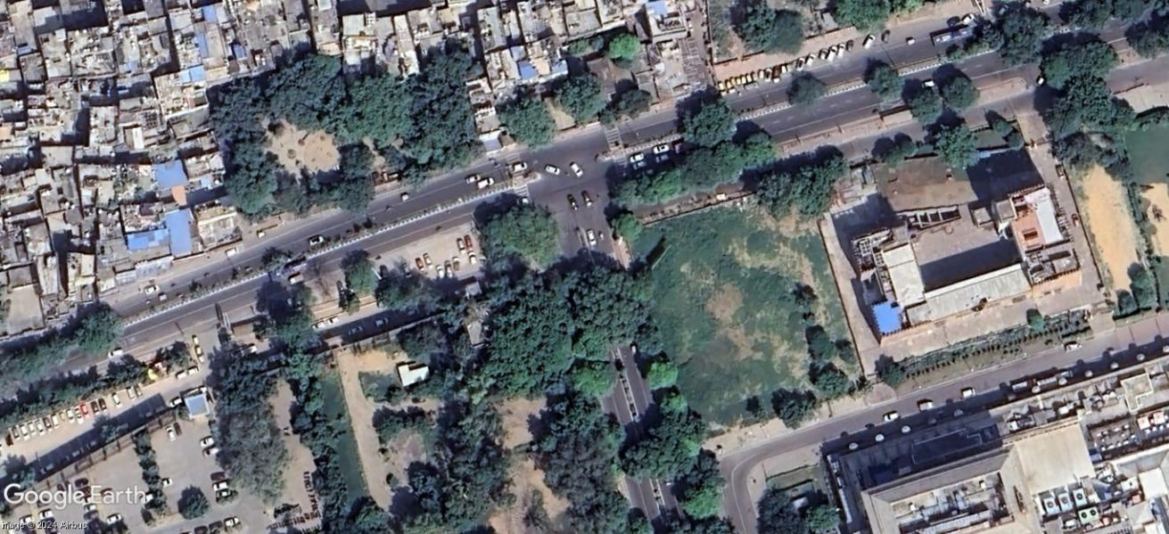

Figure 22: DJB Saket Intersectionsatellite image

### : Existing Land Use

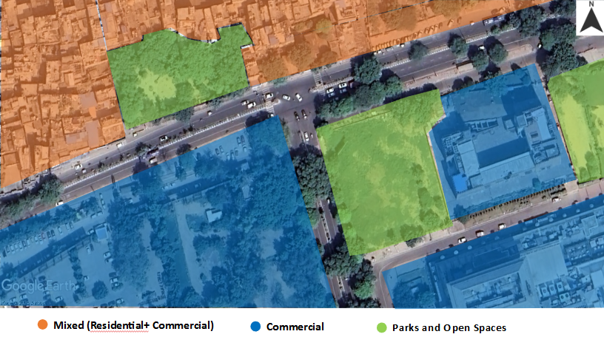

Figure 23: Existing land use near DJB Saket Intersection Intersection

### : Existing Scenario

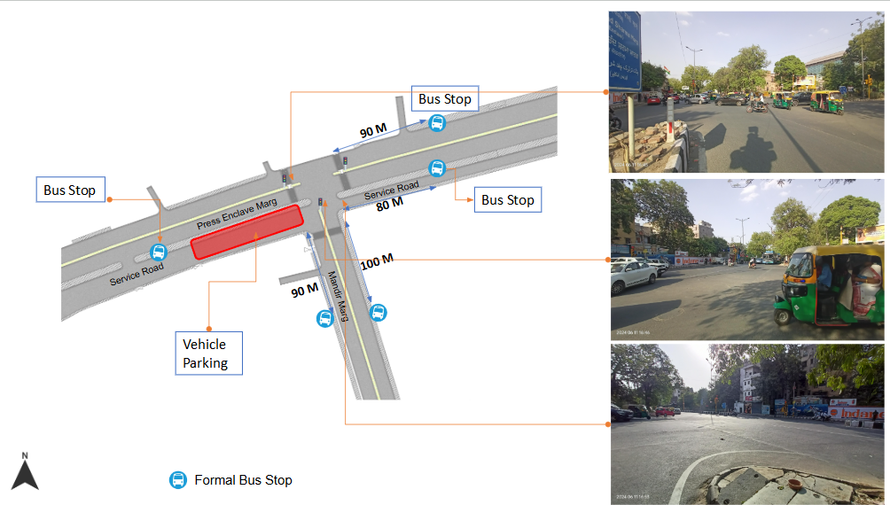

Figure 24: Existing scenario at DJB Saket Intersection 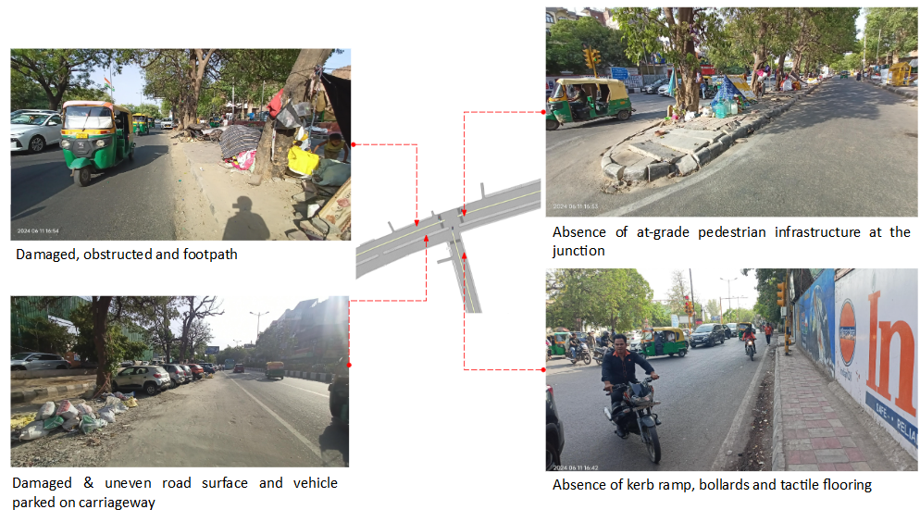

Figure 25: Existing scenario at DJB Saket Intersection

### : Issues identified

1. Absence of at-grade pedestrian infrastructure at the junction, making the pedestrians extremely vulnerable among the highspeed traffic movement.
2. Damaged and obstructed pedestrian infrastructure on each arm.
3. Parked vehicles on the carriageway
4. Damaged & uneven road surface and pedestrian infrastructure.
5. Absence of tactile flooring for differently abled users.
6. Absence of traffic calming near junctions (to control the speed of vehicles).
7. Absence of road markings, signages and speed control measures at the intersection.
8. Absence of delineators and reflectors on the median and carriageway edges.

### : Proposed Design

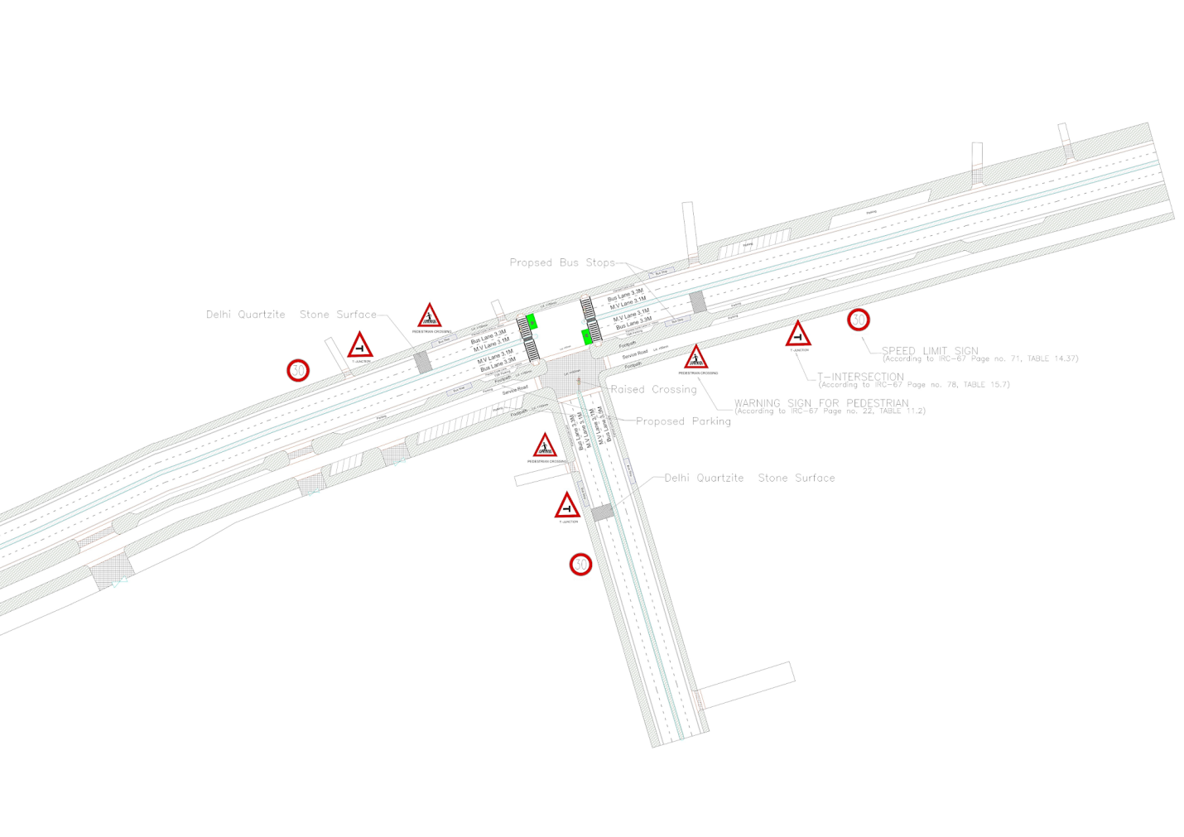

Figure 26: Proposed design for DJB Saket Intersection

1. The junction is redesigned for the speed of 30 km/hr to ensure the safety
2. Proposed new bus stop near the junction to reduce the pedestrian crossing movement
3. Proposed painted 1.2m wide cycle lane (as per IRC: 11-2022)
4. Installation of signages - Speed Limit, stop sign, pedestrian crossing and other necessary Signages on all approaching roads
5. Provision of Delhi Quartzite stone surface to slow down the approaching traffic
6. Demarcation of Road Markings (properly painted as per IRC 35)
7. Provision of kerb ramps for the accessibility of differently abled users (as per IRC:103-2022)
8. Proposed TSR and Vehicular Parking

### 

### : Summary budget estimates

| **S.No** | **Component** | **Details** | **Notes** | **Rate (per sq.m)** | **Cost (INR)** | **Cost (INR, crores)** |
| --- | --- | --- | --- | --- | --- | --- |
| **A** | **CIVIL WORK** |  |  |  |  |  |
| A.1 | Footpath (Primary, Secondary including other Flooring area) | 2m to 3m wide segregated footpath with tactile pavers | Providing and Laying of footpath 2m to 3m wide, including earthwork and base layer - PCC, GSB and finsihing material. | 3397 | 11,890,224 | 1.189 |
| A.2 | Raised Crossing | Raised crssing with 80mm thick pavers and DQ stone surface | Providing and laying Raised crosseing with 80 mm thk pavers blocks, and DQ stone including Earth work and Base layers- PCC (M15), RCC (M30 Design mix) & GSB etc. | - | 2,486,275 | 0.249 |
| A.3 | Cycle Infrastructure | 2.5m wide segregated cycle track | Providing and laying cycle track (2.5mt wide segregated) inculding Earth work and Base layers- PCC (M15), RCC (M40 Design mix) & GSB etc. also thermoplastic paint for marking and cycle symbol and spring post etc | 793 | 772,357 | 0.077 |
| A.4 | CC Items (Kerbs, Pipe, etc) | Kerb stones, Bollards, Kerb Channels etc. | Providing and fixing Kerbs, Bollards , and Kerb Channel etc. in CC. |  | 850,145 | 0.085 |
| A.5 | Signages | Mandatory, Cautoniory and Informatory Sign Boards of different sizes | Providing and fixing Signage Mandatory, Cautonory and informatory sign board inculding all the fixing and labours etc. |  | 72,548 | 0.007 |
| A.6 | Marking | Thermoplastic Paint Marking (Edge lines, Centre Line, Lane Marking, Hazard Marking, Chevron, Zebra Crossing, Bar Marking, etc) | Providing and applying road marking strips (retro- reflective) of specified shade/ colour using hot thermoplastic material for road marking . | 748 | 257,243 | 0.026 |
| A.7 | Special Zones | Provision of Sitting Bollards, CC Benches, GRC Jali, Pergola, Dustbin etc. | Miscellaneous items- Provision of Sitting Bollards, CC Benches, GRC Jali, Pargola, Dustbin etc. complete items- including foundation and fixing etc. |  | 100,880 | 0.010 |
| A.8 | Brick Work |  | Brick work with common burnt clay F.P.S. (non modular) bricks of class designation 7.5 in foundation and plinth in:Cement mortar 1:4 (1 cement : 4 coarse sand) | 7370.65/CUM | 147,413 | 0.015 |
| A.9 | Steel Reinforncement for RCC work |  | Steel reinforcement (in per kg) for R.C.C. work including straightening, cutting, bending, placing in position and binding all complete upto plinth level.Thermo-Mechanically Treated bars of grade Fe-500D or more | 107.85/kg | 43,140 | 0.004 |
| A.10 | Pavement Surface Dressing | Pavement of Bitumen layer on existing road surface | Surface dressing on old surface with hot bitumen of grade VG - 10 | 175.10 / sq.m | 1,488,350 | 0.149 |
| A.11 | Safety Management Equipment (as per design requirement) | Provision of Delieator Post, Spring Post, Cat eye/studs etc. | Miscellaneous items for Safety Management Equipment ( as per design requirement) -Provision of Delieator Post, Spring Post, Cat eye/studs etc.- including foundation and fixing etc. |  | 51,693 | 0.005 |
| A.12 | Bus Shelter | 10.5mX2.5m Bus Sheltor (Stainless Steel Strcuture) |  |  | 5,400,000 | 0.540 |
|  | **SUB TOTAL CIVIL WORK (A)** |  |  |  | **23,560,267** | 2.356 |
| **B** | Drainage, Irrigation & Plumbing | (Drainage items based on design proposal) | Drainage, Irrigation & Plumbing work @ 20% of the cost of Civil work | 20% | **4,712,053** | 0.471 |
| **C** | Electrical Work | (Light poles, junction box, other electrical works proposed based on design proposal) | Electrical work @25% of the cost of Civil work | 25% | **5,890,067** | 0.589 |
| **D** | Horticulture Work | (Landscape items based on design proposal) | Horticulture work @ 15% of the cost of Civil work | 15% | **3,534,040** | 0.353 |
| **E** | Dismantling / Demolition | -- | Dismantling work @ 15% of the cost of Civil work | 15% | **3,534,040** | 0.353 |
| **F** | Work Zone Safety & Management | -- | Work zone Management @ 5% of the cost of Civil work | 5% | **1,178,013** | 0.118 |
| **PART 1** | **SUB TOTAL PART 1 (A+B+C+D+E+F)** |  |  |  | **42,408,481** | 4.241 |
| **G** | Design Services & Support | -- | Design Consultancy (Preparation of Drawings, BOQ support, Work Zone plan, Site Supervision, Community Engagement & Liason, Change Management @ 2% - 8% of the cost of Civil work. | **2%** | **848,170** | 0.085 |
| **H** | Survey Cost | -- | Survey Cost (Total Station Survey, underground services, tree demarcation, girths , level differences, steps etc @ ( 80,000 per junction - 250m on each arm ) | 80000 | **80,000** | 0.008 |
| **PART 2** | **SUB TOTAL PART 2 ( PART 1 + G +H)** |  |  |  | **43,336,651** | 4.334 |
| **J** | Contigencies '2.5% | -- | Contingencies (@2.5% ) |  | **1,083,416** | 0.108 |
| **I** | GST('@18%) | -- | GST @18% |  | **7,995,612** | 0.800 |
| **FINAL** | **GRAND TOTAL (PART 2 + J + I)** |  |  |  | **52,415,679** | 5.242 |

**Notes:**

1. This is a preliminary estimate. Final costing to be evaluated & approved by the road owning agency.
2. DSR 2023 has been followed for all rates. Market Rate and Costing from part PWD projects has been included for certain items.
3. Cost of Drainage, Irrigation, Plumbing has been calculated at 20% of the civil work cost.
4. Cost of Electrical Work can be calculated at 20% - 25 % of the civil work cost.
5. Cost of Horticulture has been calculated at 15% of the civil work cost.
6. Cost of Dismantling has been calculated at 15% of the civil work cost.
7. Cost of Work Zone Management has been calculated at 5% of the civil work cost
8. Cost for Design Support can range from 2% - 8%, and can vary from site to site . This should include Technical Assistance on drawings, 3D supports, Site Supervision, Change management.
9. Bus Shelter has been calculated at 18 L per shelter; can be changed as per design specific cost.
10. In case of new items specific to design, please add relevant rows in detail budget estimation and include the same in the budget summary under relevant head.

## 

## : Safe School Zone: DAV Vasant Kunj

### : General description of the site

DAV Public School, located in Sector B, Pocket 1, Vasant Kunj, is a co-educational private school situated approximately 90 meters west of Aruna Asaf Ali Marg. The collector street with a varying 22 - 28 m ROW in front of the school has a land use that is predominantly institutional.  Next to the pilot DAV school, are three government schools that operate across two shifts (Government Girls Senior Secondary School & Rajkiya Pratibha Vikas Vidyalaya, Vasant Kunj in the morning and Government Boys Senior Secondary Boys School, Vasant Kunj  in evening). On the opposite side, is a vacant plot of land.

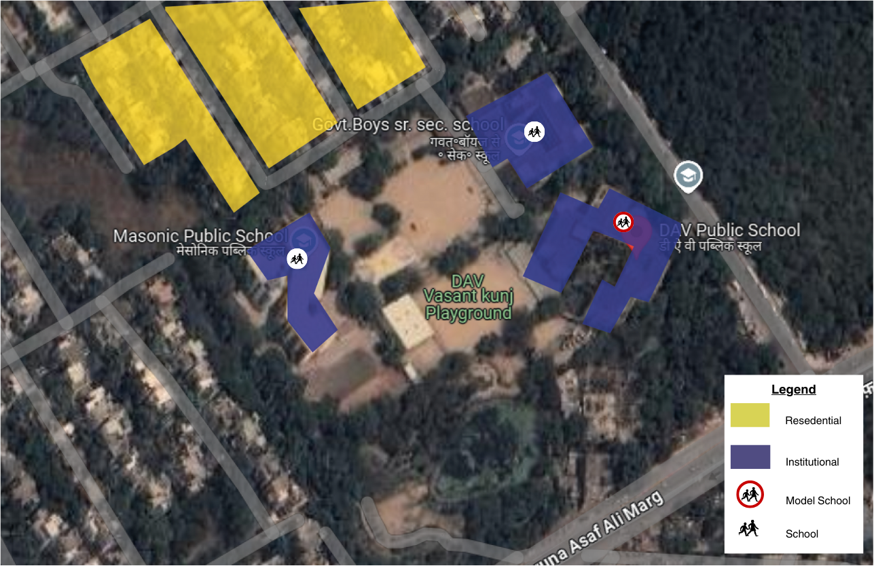

Figure 27: Land Use Map of DAV Vasant Kunj (AY 22-23)

DAV Public School has a total enrollment of 2200 students (as per the academic year 2022-2023), from class Nursery to 12 (age 4  to 18). The school has a total of three gates that open on the collector street. All the three gates are used during the entry/exit hours. Gate 01 is used by staff that commute by private vehicle as well as exit for buses, and gate 03 is used by primary students, and gate 02 is used as a main entrance. All gates are used for the exit hour for middle and senior students. The government school has two gates; gate 01and gate 02 are used by both shifts to enter and egress from school premises. The main modes of transport in DAV public school are school bus, and vans, whereas for the government school, it is predominantly walk.

The graph below shows the data collected online via road safety clubs for DAV Public School. Walking and cycling are observed to be the largest modes of transport in the government schools.

### : Existing Scenario

As per a travel survey conducted in Dec ‘22, response from  147 students (13% of total school population) was mapped to understand travel patterns and socio-emotional data relevant to school journeys.

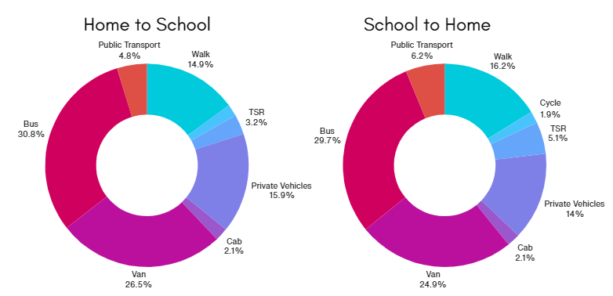

Figure 28: **School Travel Data**

*Source: HumanQind School Travel Survey 22-23*

* School buses and vans make up for more than 50% of the modal share of the school.
* Around 15% of the students use private vehicles and 15% of them walk.
* Less than 2% of the students cycle and 4% of them use auto rickshaws.
* 5% of the students use public transport.

There is no significant difference in the mode choices in the morning and afternoon.

### : Issues identified

**Observations on Road Infrastructure:** Due to the traditional vehicle-centric planning approach, the road infrastructure does not promote pedestrian safety and creates an unsafe environment for the vulnerable road users, putting school children at risk. High conflict between vehicles and students is observed especially during the entry/exit hours of school. This puts the students at risk of injuries. Many students and parents have also mentioned challenges they face while crossing the Asaf Ali Marg intersections with high speed vehicles. Lack of traffic calming, accessible and continuous footpaths, safe space to cycle safely, signages and marking, and lack of parking spaces, are some of the visible issues.  Encroachments and obstacles on the existing footpath include parking of private vehicles, piles of garbage, and other infrastructure like taxi stands. Other obstacles on the existing footpath include scatteredly  placed street lights and other poles, unflushed manholes and other utilities. With that there is a lack of integrated green areas, waiting spaces, play zones and vendor areas. Students walk and cycle between parked vehicles on footpaths and spill to the carriageway in large numbers. No drop off and pick-up areas have been assigned for bus and vans. Due to lack of street lighting, the street is dark, unsafe and unusable in late evening and night hours.

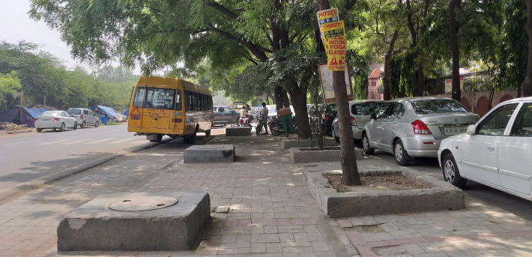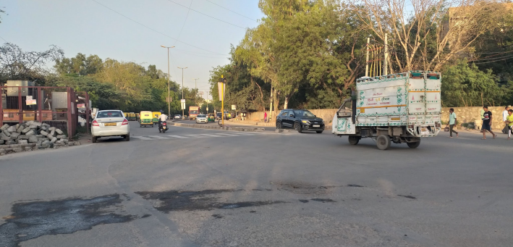

Figure 29: Site Photographs : Footpath with raised drains and parked cars in front of DAV Public School (Left), Aruna Asaf Ali intersection with lack of safety and traffic calming measures (Right)

**Type and quality of enforcement:** Unorganised parking of buses and vans around the school gates at the street during the entry/exit hours is observed. The parked private car further makes the pedestrian path insufficient hence the children walking spill over to the carriageway. On the adjacent side of the street, near the government school during the GGSSS exit hours, the waiting students for GBSSS shift occupy the street and it becomes difficult for the girls to walk between the crowds. With lack of a management team and any other traffic safety personnel the environment around the school becomes uncontrolled and unsafe, this also delays the movement of students and school vehicles leading to congestion and chaos on the street.

**Road users behaviour and mobility patterns:** To understand the patterns of movements and conflicts in the school zone, activity mapping was conducted in morning hours (home to school traffic) and exit timing during afternoon (school to home).

An activity map documents all kinds of street users including vendors, vehicular movements & parking in a particular road environment specific to a certain time duration.

**Fear experienced during school travel:**  About 60% of the students feel unsafe during their travel to school. Students travelling from vans reported the highest amount of fear, 93% both in the morning and afternoon hours. About 40% of the students who walk also reported feeling unsafe. Public transport and auto rickshaws were reported to be safer modes of travel than others. (Source: HumanQind Safe School Zone Survey 22-23)

**Infrastructure Interventions required:** About 67% of students responded that they want traffic lights and safe crossing, footpaths for walking and organised entry and exits. With that 66%, and 65% students respondents wanted no crowding outside school and comfortable waiting areas. 58 % of respondents also opted for vehicle free streets.(Source: HumanQind Safe School Zone Survey 22-23)

**Infrastructure Interventions and Academic Performance:**  Academic performance is not a result of a child's ability and focus alone; rather it is a combination of various factors, of which travel to school is an important one. Noise, long hours of travel and lack of transport can impact the energy levels and the stress experienced by the student. This can impact the learning experience and performance of the students.

74% of the respondents wanted less noise outside school to improve upon academics.  51% voted for less travel time, 48% opted for availability of public transport near school and 44% also responded to less walking time that helps them perform better in academics.(Source: HumanQind Safe School Zone Survey 22-23)

### : Activity map

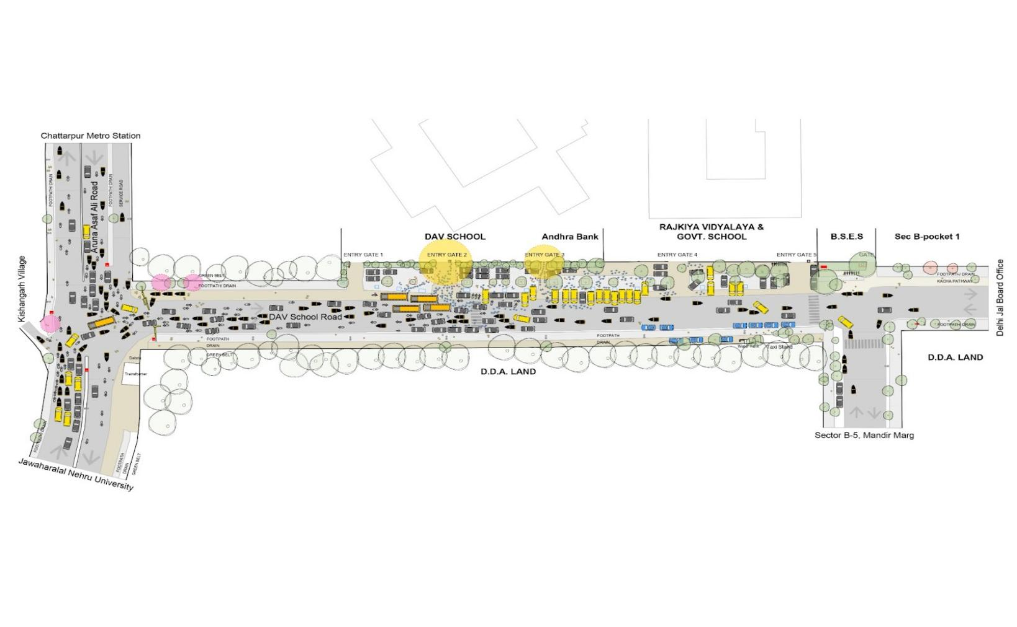

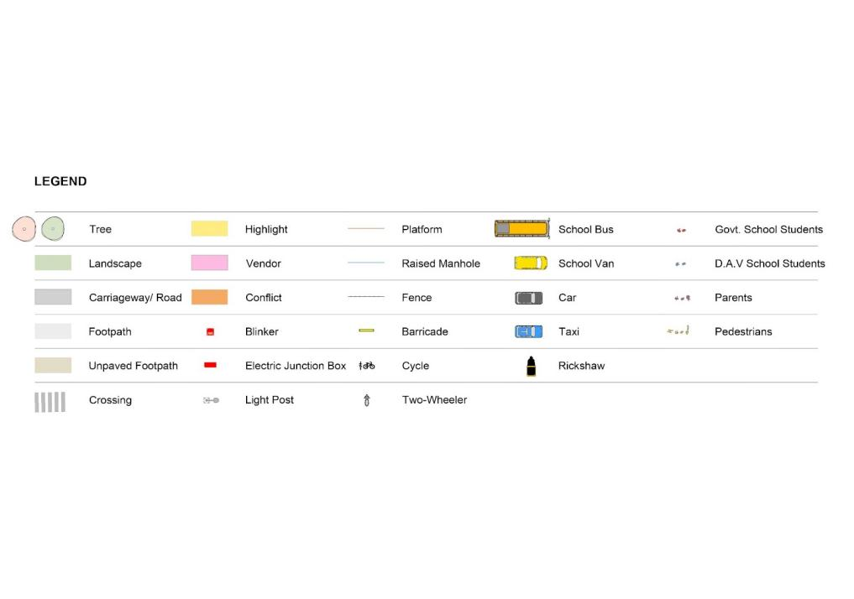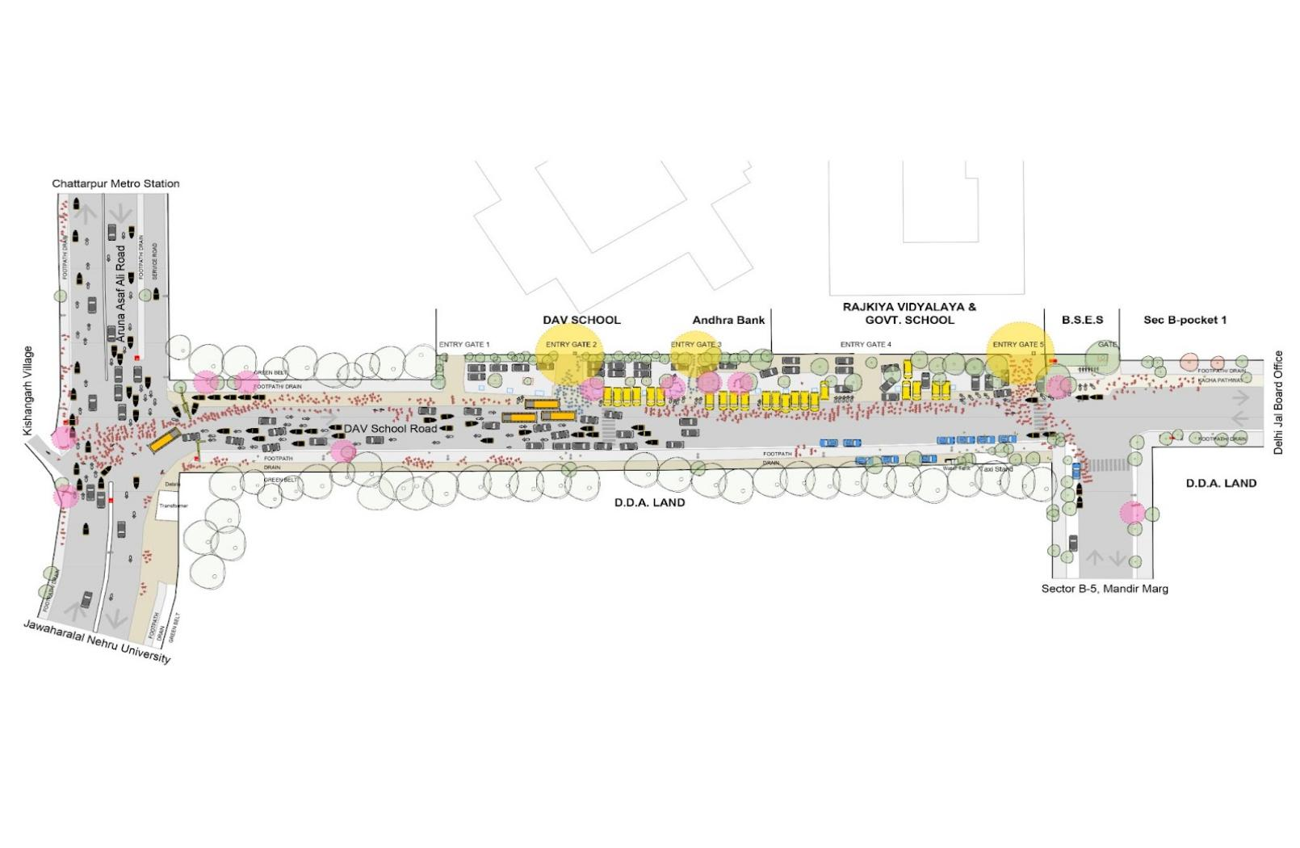

Figure 30: Activity mapping at DAV Vasant Kunj (Home to School - Up, and School to Home - Down)

**Key Findings:**

|  |  |
| --- | --- |
| **Morning : Home to School**   * Conflict between students and speeding motorised vehicles is observed during the school entry hours. * Lack of dedicated drop off zones leads to unorganized movement and parking of vehicles on footpath and in front of the school gate. * Unorganized parking - car and van parking creates conflicts and reduces the street to school visibility and vice-versa. This pushes students in unsafe conditions | **Afternoon : School to Home**   * High conflict between students (particularly who walk) and speeding motorised traffic is observed during the entr/exits schools. * Mothers / caregivers wait without any designated safe and comfortable waiting area outside school * For shift schools, the exit hours of the Govt. Girls School overlaps with the Govt. Boys school entry hours. Boys student wait near the gates before the school hours with insufficient waiting spaces/ areas. The girls walk on the carriageway with the high speed traffic on the road. * Lack of designated drop off and pick up areas. * Parked vehicles lead to chaos and difficulties in navigating, occupying the space for pedestrian pathways. |

### : Proposed design

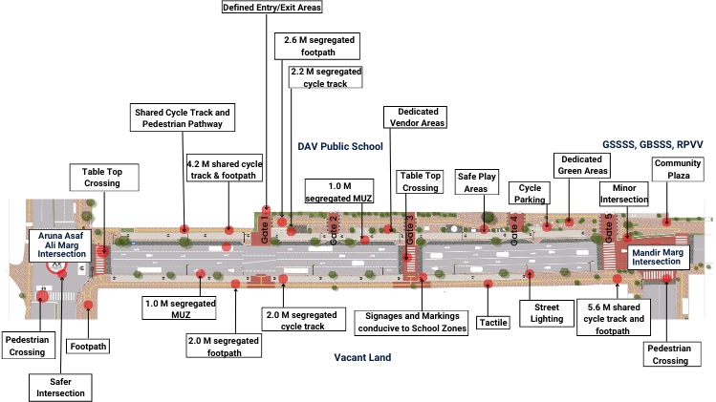

Figure 31: **Proposed School Zone Plan for DAV Vasant Kunj**

**DESIGN INTERVENTIONS**

The proposal prepared road safety club (Refer Safer Delhi through Road Safety Clubs) is called ‘250 Meters of Happiness’ aligning to pedestrian first approach, traffic safety principles, UN Sustainable Development Goals and Ladder of Children Participation. ‘250 Meters of Happiness’ is an area plan connecting 4 schools (1 private and 3 public) and the neighbourhood for school zone development with 250 M of the street stretch in front of school gates. The entire plan is in adherence to Indian Road Congress Guidelines. To reduce speeds and conflicts, the school zone has been designed as per 20km/h or lower speed, promoting walkability and safe mobility for children and school community. Continuous footpaths with designated boarding areas and drop off zones have been proposed spanning from Asaf Ali Marg Intersection to Mandir Marg Intersection.

The Right of Way (ROW) and intersection design has been designed as per the street typology.

* 2.0-2.6m accessible and segregated footpaths on both sides.
* 2.0-2.2 m segregated cycle lane on one side. (as per IRC 11: 2015)
* 1.0 m of Multi-Utility Zone for Services such as lighting, signages, and drainage.
* Traffic calmings designed in front of entry/exits and school gates.
* Designated boarding areas and drop off zones
* Integrated waiting spaces and different kinds of street furniture like benches, pergola and table chairs
* Integrated community plaza near the Mandir Marg intersection
* School specific signage and marking
* Dedicated rubber flooring with interactive play areas for students
* Dedicated vendor zones
* Integrated tactile and wheel-chair friendly ramps
* Integrated green spaces with other newly proposed trees on the opposite side of the school
* 50 M long interactive street art
* 11 Glass Mosaics Artwork on the pedestrian pathway
* Continuous 2 lane carriageway on the road in front of school.

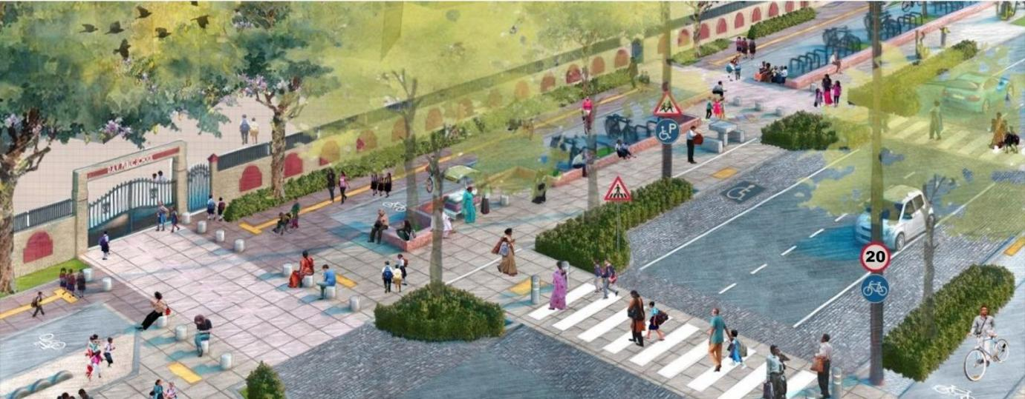

Figure 32: Render of the p**roposed intervention front of DAV Vasant Kunj**

**Estimated budget -**  Project Complete (2024)

Source: Development of road side of DAV School road stretch in front of Govt. School and DAV School for making it pedestrian student friendly under Sub Division III of Division South Road, PWD, New Delhi (SH: Civil + Elec Works). Public Works Department, Delhi

**Project Implementation - 250 meters of Happiness, DAV Public School, Vasant Kunj**

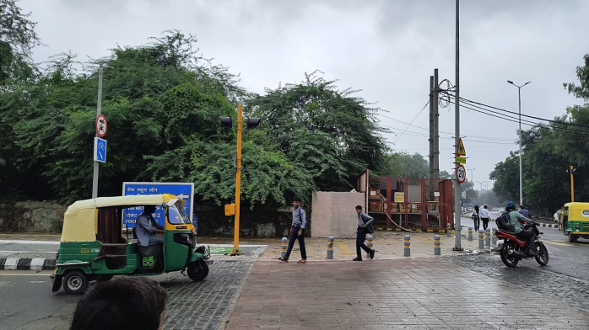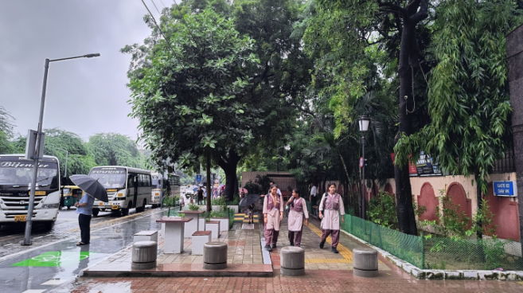

Figure 33: **(Left) - Pilot School Zone South  District - Raised Crossings at Asaf Ali Marg Intersections**

Figure 34: (Right) - Pilot School Zone South - Students walking on safe and accessible pedestrian paths, cycle track

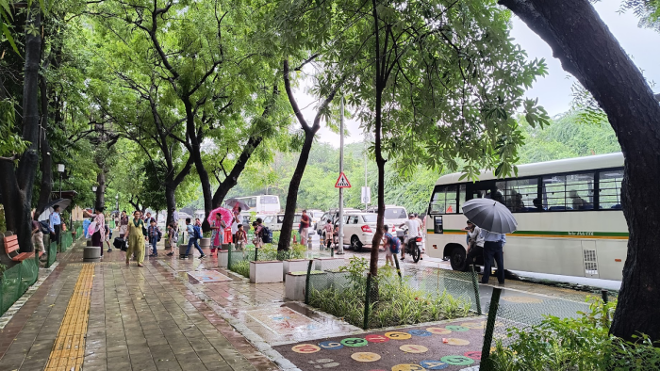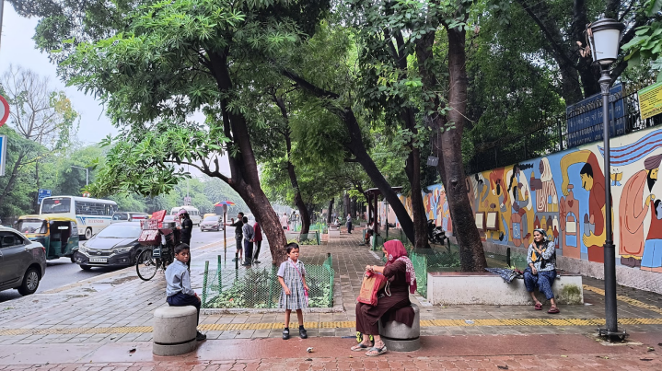

Figure 35: (Left) - Pilot School Zone South - Student using Dedicated drop off zone. Learning aid, vendor spaces, green areas and waiting spaces integrated as part of pedestrian environments

Figure 36: (Right) - Waiting area and street art in front of Government school

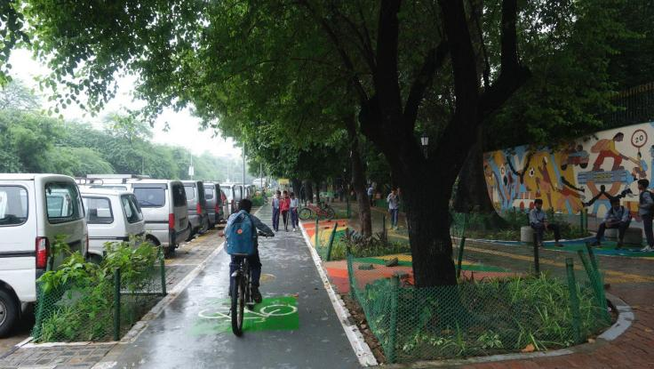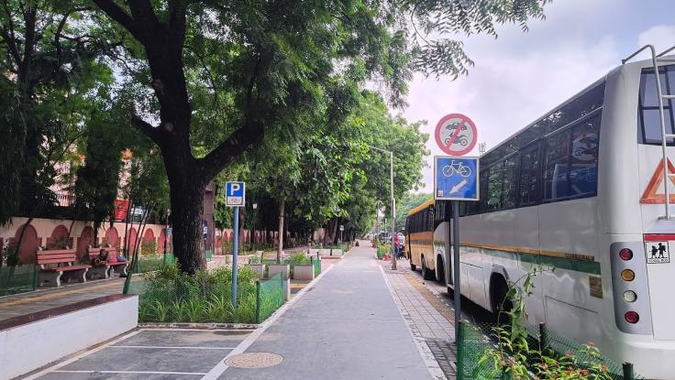

Figure 37: (Left) - School students using the newly built segregated cycle track during school commute

Figure 38: (Right) - Segregated Cycle Track with cycle parking separated by Multi Utility Zone with signages (as per IRC 67: 2022) and street lighting

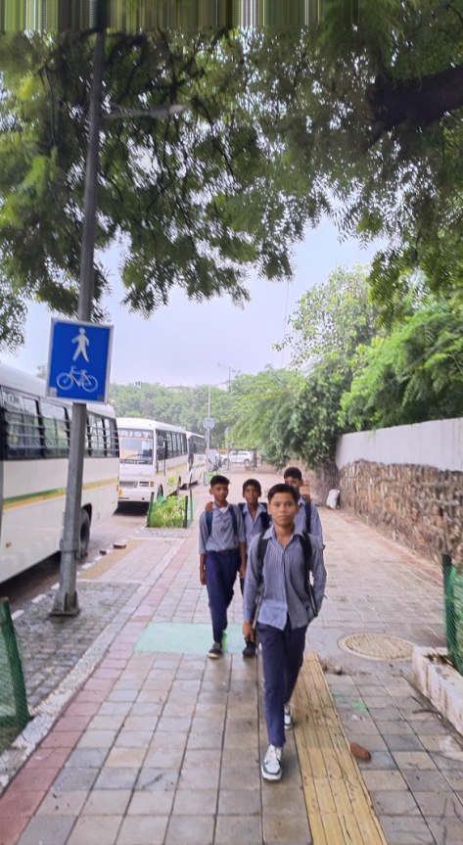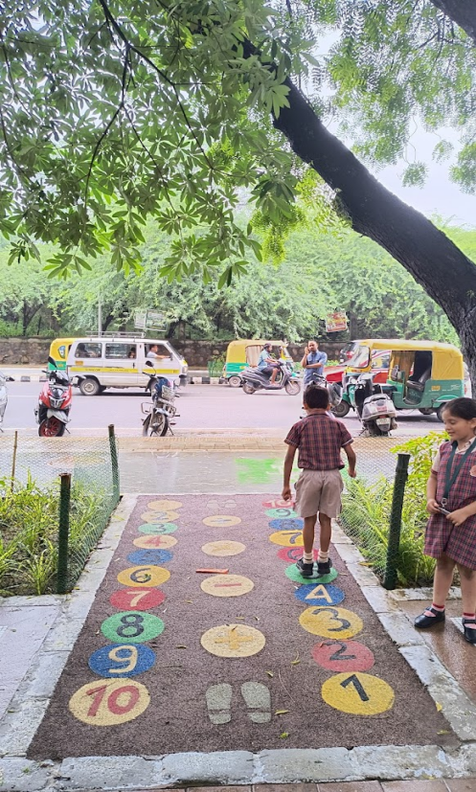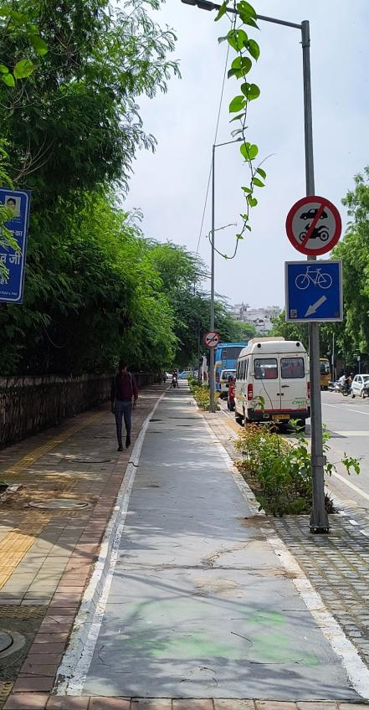

Figure 39: Safe NMT Infrastructure segregated on both sides (Left); Learning Aid integrated with NMT Infrastructure for students  (centre); Students walking to school from intersection (Right)   
  
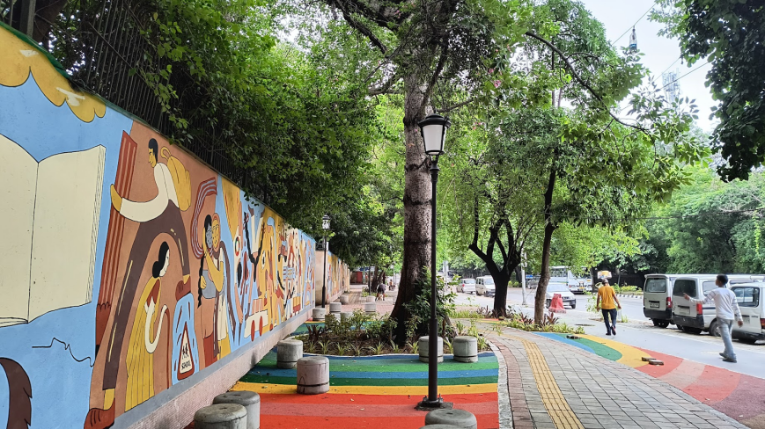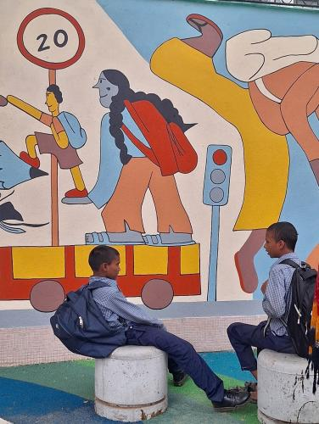

Figure 40: Area between schools used as a shared space with SDG floor corner street art - safety promise and play and gym areas (Left): Students using the corner for waiting and learning about road safety principles (Right)

**Link to the appendix report: <https://tripc.iitd.ac.in/publication/report>**

